# RAVI KANT

**CURRICULUM VIATE**

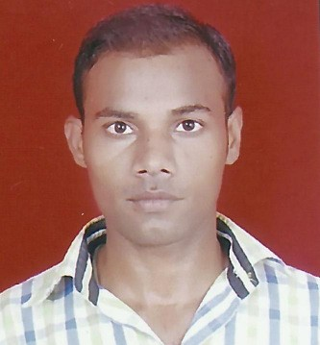

B-2/259, HARSH VIHAR, DELHI-110093

### Contact Number : 9650182216 Email Id : [ravikant1192@gmail.com](mailto:ravikant1192@gmail.com)

* **CAREER OBJECTIVE :**
* To work in a challenging and world class environment and to use my knowledge and skills to achieve organizational goals.

### TRAINING :

* One Month Training Of **Automobile** Including Work at Safdarjung Airport, Delhi.

# WORKING EXPERIENCE :

* One Year Experience In **Minda Furukawa Electric Pvt Ltd**, Under the Training Of **Diploma Trainee Apprenticeship**, at Noida ,Sector-67,(UP)

# PROFESSIONAL AND TECHNICAL QUALIFICATION :

|  |  |  |  |  |
| --- | --- | --- | --- | --- |
| **Course** | **Institute** | **Board/University** | **Year** | **Percentage** |
| **3 Year Diploma In** | Guru Nanak Dev | **GOVT. OF NCT OF** | 2011-2014 | **70.61%**  57.58%  60.58%  70.90%  71.83%  70.69%  79.00% |
| **Mechanical** | Polytechnic Rohini , | **DELHI,** |  |
| **Engineering** | Sector |  |  |
|  | -15,Delhi-110085 | BOARD OF |  |
|  |  | TECHNICAL |  |
| **SEMESTER** |  | EDUCATION, |  |
|  |  | DELHI |  |
| I. Nov/Dec. 2011 |  |  |  |
| II. May/June 2012 |  |  |  |
| III. Nov/Dec 2012 |  |  |  |
| IV. May/June 2013 |  |  |  |
| V. Nov/Dec 2013 |  |  |  |
| VI. May/June 2014 |  |  |  |

* **ACADEMIC QUALIFICATION :**

|  |  |  |  |
| --- | --- | --- | --- |
| **Course** | **School** | **Board** | **Year** |
| 12th | Govt Boys Senior Secondary School | C.B.S.E. | 2010 |
| 10th | Govt Boys Senior Secondary School | C.B.S.E. | 2008 |

* **ADDITIONAL CERTIFICATES:**
* 3 Month Certificate Course Of **Basic Of Computer**.
* 3 Month Certificate Course Of **Autocad** From Sarvodaya Institute,Durgapuri, Delhi-110093

# STRENGTHS:

* Self - Motivated And Self Believing.
* Believe In Will Power, Flexible And Friendly.
* Positive Thinking , Hard And Smart Working.
* Sincere And Hard Working Capacity.
* **PERSONAL INFORMATION**

Name : RAVI KANT

Father’s Name : BANKEY LAL

Date of Birth : 01 JAN.1992

Contact No. : 9650182216

Sex : Male

Marital Status : Unmarried

Nationality : Indian

Language Known : Hindi, English

Hobbies : Playing Cricket,

# DECLERATION:

## I here by declare that the above statement is true to the best of my knowledge &belief. Date :

Place : (RAVI KANT)