**RESUME**

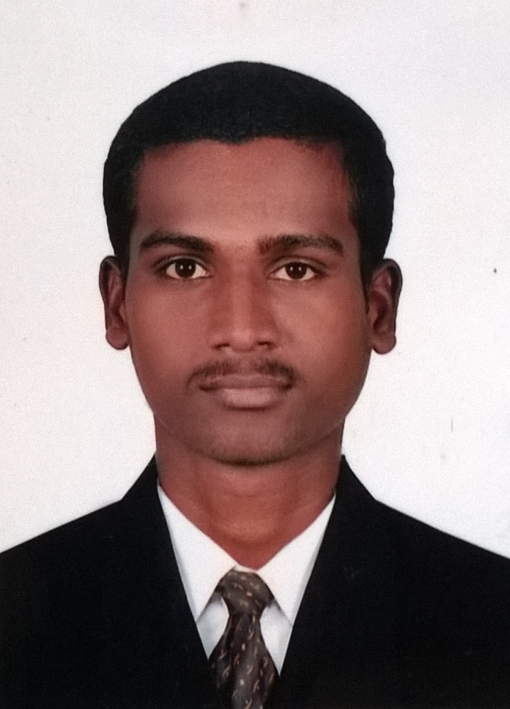

**MANIKKAM M**

24,Eswaran kovil street,

Avalpoondurai,

Erode-638115.

Email ID : [manickam3201@gmail.com](mailto:manickam3201@gmail.com)

Mobile No : +91 7373614416

**CAREER OBJECTIVE**

To held a responsible positions, where my skills are strengthened and utilized for the execution of challenging opportunities in a reputed organization.

**EDUCATIONAL QUALIFICATION**

|  |  |  |  |  |
| --- | --- | --- | --- | --- |
| **Qualification** | **Institution** | **University/**  **Board** | **Year**  **of passing** | **Percentage/CGPA** |
| B.E  [Mechanical Engineering] | Jayshriram group of institutions -Tirupur | Anna University- Chennai | 2015 | 6.8% |
| DIPLOMA  [ Mechanical Engineering] | Al-Ameen polytechnic college, Erode. | DOTE | 2012 | 81.25% |
| S.S.L.C | Govt. Hr.Sec.School,  Avalpoondurai, Erode. | State Board | 2008 | 77.12% |

**FIELD OF INTEREST**

* Production
* Designing
* Maintenance

STRENGTH

* Responsible Attitude
* Ability to work both individually as well as in a team
* Sincere and hard working
* Quick Learner

**CO-CURRICULAR ACTIVITIES**

* Participated in **“Drawing competition”** at Jayshriram group of institution, Tirupur.
* Member of **“ISME”**.

**PROJECTS**

* Demonstrated a project on **“DOUBLE TRAILER SYSTEM”** in Al-Ameen polytechnic college, Erode.
* Mini project on **“HYDRAULIC LOG SPLITTER”** in Jayshriram group of institution, Tirupur.
* Main project on **“FLOW SIMULATION AND COMPARISON ANALYSIS OF A CONDENSER WITH AND WITHOUT AN ALUMINIUM COIL FIN”** in TNPL, karur.

**INDUSTRIAL VISITS**

* One day visit to **Rane Brake Linings**, Trichy.
* One day visit to **Barani Ferro Casting Limited**, Coimbatore.
* Three days visit to **Barani Hydraulics India Private Limited**, Coimbatore.

**SOFTWARE SKILLS**

* **AUTOCAD**
* **PRO-E**

**EXPERIENCE**

* SL LUMAX Private Limited, Chennai. – 1 year (Production Engineer)

**PERSONAL DETAILS**

Father’s Name **:** Mr. A.MADESWARAN

Date of Birth **:** 10th May1993

Gender **:** Male

Nationality **:** Indian

Languages Known **:** Tamil and English

**DECLARATION**

I hereby declare that all the above furnished details are true and verified to best of my knowledge.

**PLACE: YOUR`S TRULY**

**DATE : (**MANIKKAM .M**)**