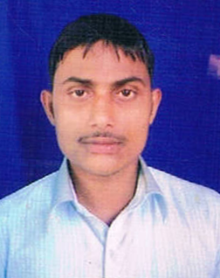**CURRICULUM VITAE**

**Vaseem khan**

***ADDRESS:***

***Vill & Post – Shahpur Kheri***

***Distt- Bijnor (U.P.)-246727***

***Country- India***

***Mob-+91-9627183639 Email-vaseemk720@gmail.com***

**CAREER OBJECTIVE:-**

To work for an organization that offers career growth and a chance to achieve goals through persistence and hard work where I can utilize my current skills and potential for organizational as well as personal growth.

**ACADEMIC QUALIFICATION:-**

* B.A from M.J.P.R.U Bareilly in the year 2013.
* Intermediate from U.P.Board in the year 2010.
* High School from U.P. Board in the year 2008.

**OTHER QUALIFICATION:-**

* Basic Computer Knowledge

**WORKING EXPERIENCE:-**

* Six Month Experience in trumpets from MGF Mega City Mall Gurgawa.
* 3 year Sales Excutive Experience as a Spencers Hypers Gurgoan Haryana.

**PERSONAL PROFILE:-**

**Passport No : N1478173**

**Date Of Birth :** 03-Mar-1993

**Father’s Name**  :    Mr. Nazare Hasan

**Mother’s Name**  : Mrs. Amina Khatoon

**Gender :** Male

**Marital Status :** Unmarried

**Language Known :** Hindi, English

**Hobbies**  : Listening music, Reading Books.

**DECLARATION:**

I hereby declare that the information given by me is correct and nothing has been hidden in it. The information is true to believe to the best of my knowledge.

Date:

Place: **(Vaseem Khan)**