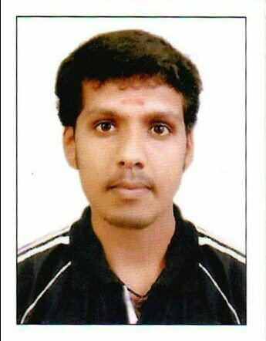**Sachin prakash**

## [sachin.mannar@gmail.com](mailto:sachin.mannar@gmail.com)

+918547787068

**CAREER OBJECTIVE**

Looking for a challenging career which demands the best of my professional ability in terms of technical and analytical skills,and help me in broadening and enhancing my current skill and knowledge.

# SKILLS

Computer knowledge, ms ofﬁce

# WORK EXPERIENCE

Jul-2015 - Mar-2016 **Daewoo e&c qatar**

Safety ofﬁcer Provide good health & safety working environment.

Site monitering

Fire extinguisher inspection Checking ppe

Dec-2014 - Feb-2015 **Plustech engineering gujarath**

Safety superviser Site inspection.

Provide incident free working site Jan-2012 - Dec-2014 **A P U enterprises mumbai** Safety ofﬁcer

# PROJECT DETAILS

### Project Name: Site visit and ﬁnding hazard

**Role:** Safety ofﬁcer **Team Size:** 1 **Project Duration:** 1 Day

**Project Detail** Find number of hazards occur in construction site and how to reduce hazards

# EDUCATION DETAILS

|  |  |  |
| --- | --- | --- |
| Degree/Course | Percentage/CGPA | Year of Passing |
| **Diploma in ﬁre and safety** | 68 % | 2011 |
| Iifs mavelikkara , Punjab technical university |  |  |
| **Nebosh** | 65 % | 2015 |
| Iifs mavelikkara , Uk certiﬁcate |  |  |
| **Iosh** | 60 % | 2014 |
| Iifs mavelikkara , Uk certiﬁcate |  |  |

|  |  |  |
| --- | --- | --- |
| **Sslc**  Nshss mannar , Kerala general education dept | 80 % | 2007 |
| **Plus two** | 77 % | 2009 |
| Nshss mannar , Kerala Higher secondary board |  |  |

**HOBBY**

Reading books,net browsing,playing cricket

# PERSONAL DETAIL

Address Jyothis vishaversarikkara mannar po chengannur Alappuzha, Kerala, Pincode 689622

Date of Birth 1/2/1991

Gender Male

Nationality India

Marital Status Single

Languages Known English,hindi,tamil,malayalam

# REFERENCES

### Pradeep kumar

Manager A P U enterprises mumbai

9820301369 [rugminiindustries@gmail.com](mailto:rugminiindustries@gmail.com)

# DECLARATION

I hearby declare that above written particulars are true and correct to the best of my knowledge and belief.

## Sachin prakash