**Curriculum Vitae**

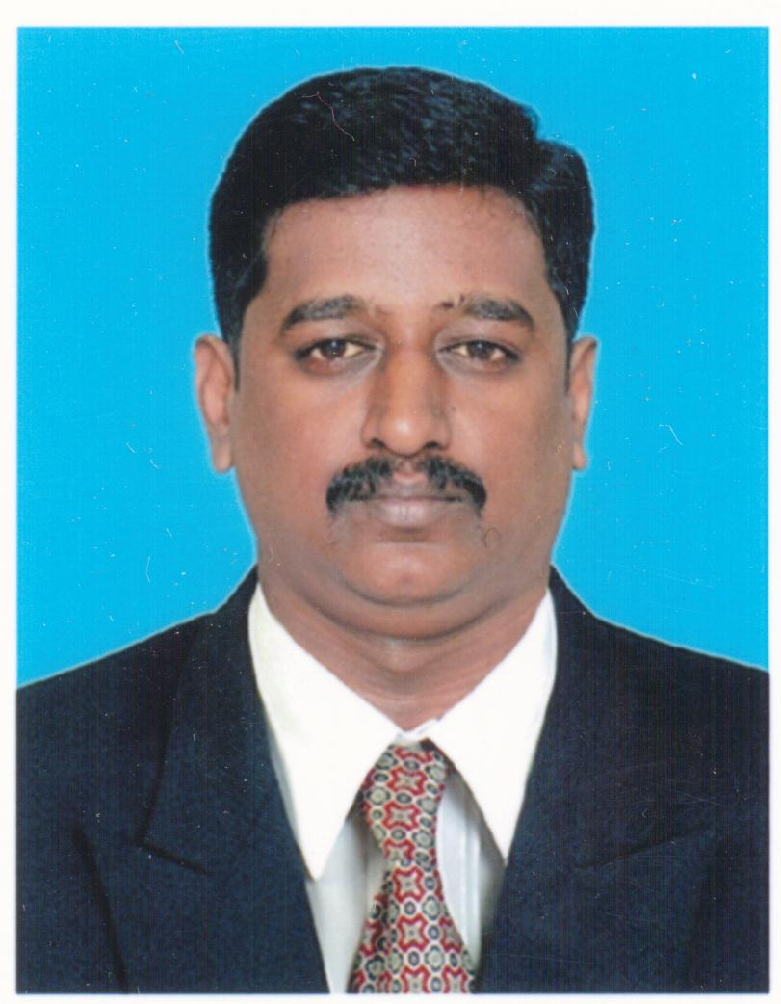

**K.VIJAYABABU**

 7806960221 , 8667498016

Skype Id : vijaygp2

E_mail : vijayjobs2015@outlook.com

vijayjobs2014@outlook.com

**Objectives:**

* Looking forward for **Electrical Site Engineer at CONSTRUCTIONS , Oil & Gas and MEP service** in a reputed organization that gives me an opportunity where I can improve my ability to share my skills and to be a part of success in that Organization.

**Professional Synopsis :**

* 10 years of total experience wherein 2yrs as Construction Electrical Site Engineer in Apartments , Villas projects , and 8yrs as Electrical Supervisor in High Rise Building , Commercial Malls , Gulf Government Hospital, Sports stadium & hall Projects in Gulf countries.

**Educational Qualification**

***B.E ELECTRICAL & ELECTRONICS ENGINEERING*.**

*Institute : Anna University –Madurai (Part Time)*

*Year of passing : 2016 (Evening Mode)*

***DIPLOMA IN ELECTRICAL & ELECTRONICS ENGINEERING.***

*Institute : Lakshmi Ammal Polytechnic, Kovilpatti.*

*Year of passing : 2001 with First Class (Full Time)*

**Passport Details**

Passport No : L5686304

Valid Upto : 19-12-2013 to 18-12-2023

**Additional Qualifications**

**Certificate course in Autocad (Electrical)**

Institute : CADD Centre

Year of passing : Oct 2007

**PG Diploma in Computer Application**

Institute : BDPS Software Limited, Mumbai

Year of passing : July 2002 Second class

**Diploma in Computer Hardware**

Institute : Wintech Computer Education, Tirunelveli

Year of passing : April 2002 first class

***GULF* Work Experience** : ***4yrs***

* ***Organization : Black Arrow Integrated Technology - Qatar***

*Job profile : Working “ Site Supervisor & Draftsman ”*

*Period : From July 2014 to FEB 2015*

**Project details**

* ***ALSADD SPORTS CLUB HANDBALL STADIUM (Supervisor & Drafts Man)***

***(SECURITY SYSTEMS) – QATAR***

* ***HAMAD MEDICAL CORPORATION QATAR GOVT HOSPITAL OPERATION THEATER EXTENSION BLOCK & CARPARKING – QATAR(low current system)***

**Job Responsibilities**

* LOW CURRENT SYSTEM DRAWING Preparation & Site Supervising , Installation ,

Pre-Commissioning checks in of DOOR ACCESS CONTROL , MASTER CLOCK , SMATV, CCTV SYSTEMS – HAMAD Medical Corporation GOVT HOSPITAL - QATAR

* SECURITY SYSTEMS DRAWING Preparation & SITE SUPERVISING installation of UNDER VEHICLE SURVILLENCE SYSTEM(UVSS), ROAD BLOCKER & GATE BARRIER , HYDRALIC BOLLARDS AT ALSADD HANDBALL STADIUM - QATAR .
* Material and Manpower Allotment, Equipment Arrangement , start card for the Execution of work .
* Checked material availability in store, indent making and reported to project engineer.
* Request for instruction and Daily work-done Report Prepared and submitted to project Engineer.
* Attend the Weekly Meeting with project Engineer and project manager at head office .
* Weekly attended & Contacted Safety meeting and toolbox talk given the safety instruction to labor as per safety officer instruction.

***Organization : ETA - Ascon (Emco-Division) - Abu Dhabi***

*Job profile : Worked as “Electrical site Supervisor & Draftsman”*

*Period : From March 2008 to May 2009*

**Project details**

* ***130 STAFF ACCOMMODATION & MULTIPURPOSE SPORTS HALL GASCO BUHASA PLANT PROJECT – ABUDHABI ( SUPERVISOR & DRAFTSMAN )***
* ***ALAIN GOVERNMENT AL-JIMI HOSPITAL (MEP) MAINTENANCE PROJECT – ALAIN(SUPERVISOR)***
* ***GAYATHI MUNICIPALITY VILLAS & COMMERCIAL BUILDING MAINTENANCE PROJECTS – GAYATHI AND SILA (ABU-DHABI)(SUPERVISOR)***

**Job Responsibilities**

* Electrical Drawing preparation ,SLD, SCH, LIGHT,POWER ,EMERGENCY SYSTEM,FIRE SYSTEM in AUTOCAD and LOAD SCHEDULE PREPARATION submitted to Project Engineer for approval**.**
* Supervising & installation of the LIGHTING, POWER,COOLING SYSTEM,UPS,CCTV,TEL-DATA ALSO FIRE SYSTEMS,MDB,SMDB,DB network, lightning protection system as per Scope of work.
* Material and Manpower Allotment, Equipment Arrangement for the Execution of work .
* Checked material availability in store, indent making and reported to Project engineer and material coordinator.
* Request for instruction and Daily work-done Report Prepared and submitted to project Engineer.
* Following higher management time schedule instructions and advices, reporting work field condition problems & statues to higher management, following activities of other departments in site.
* Attend the Weekly Meeting with project Engineer and project manager at head office .
* Weekly Attended & Contacted Safety meeting and toolbox talk given the safety instruction to labor as per safety officer instruction.
* **Organization : *International Electro-Mechanical Service Company-Dubai***

*Job profile : Worked as “Electrical Forman ”(MEP)*

*Period : From August 2005 to August 2007 (2yrs)*

**Project details:**

* ***MARINA HEIGHTS TOWER, 56 FLOORS PROJECT -JUMERIA-DUBAI.***
* ***DUBAI AIRPORT FREE-ZONE(DAFZA) 9 FLOORS PROJECT -DUBAI.***
* ***EMIRATES AIRLINES HEAD QUARTERS, 9 FLOORS PROJECT -DUBAI.***
* ***BURJ LAKE HOTEL 63 FLOOR PROJECT - DUBAI.***

**Job Responsibility**

* Supervising & Installing of LIGHTING, POWER ,UPS,CCTV,TEL-DATA , FIRE ALARM SYSTEMS and Termination of Cables MDB,SMDB,DB ,AHU , DG ,TRANSFORMER,ATS in to panel board as per approved electrical drawing.
* All type of Electrical wiring: Domestic and Industrial,

Lightning & Earthlings network .

* Pre-Commissioning checks in MDB,MCC,SMDB,DB,DG, Sets panels.
* Fire alarm & Public Address system and Emergency system work.
* MDB,MCC,DG,UPS,SMDB,DB Cable Termination and dressing Work.
* Operation, Control, Maintenance of LT Motor and Starters.
* Tray and Trunking Cable Laying Upto 400 & 630 sqmm Cables ,

Control Cables and Termination of cables .

***India work Experience :******6yrs***

* ***Organization : Anjali Construction - Tvm Kerala***

*Job profile : Worked as Site Engineer.(Electrical)*

*Period : From May2015 to Till date*

***Project details:***

***Multi-story Building , Commercial Building, Apartments , Hotels & luxury villas ELECTRICAL projects in kerala***

* ***ANJALI SQUARE projects 4block B1+G+10Floor – Kerala***
* ***ANJALI APPRATMENTs 10block projects B1+G+12Floor-kerala***
* ***ANJALI LUXURY VILLAS Project 40nos – Kerala***

**Job Responsibilities:**

* Providing on-site design services following scope of work, shop drawings. supervising the installation of the LIGHTING, POWER,CCTV,TEL-DATA ,FEEDER PILLAR , SMDB,DB network , Fire Fighting system.
* Preparation of Single line diagram layouts, specification for Electrical Equipment such as Transformers, Energy meter, Fuses, Circuit Breakers (MCB,MCCB), RYB cables, Distribution Boards, etc
* Prepare daily report regarding inspections, material, Non conformances etc

Checking the drawings and documents used at site for approvals and compliance with project requirements.

* Conduct inspections for all electrical material deliveries
* Check and File the Documents of scope of work , drawings, BOQ Preparation ,indent and invoice copy, material quotation , sub-contractors work executed details and manpower Allocated and filed regularly in the schedule of site work updated.
* Meeting with Project Manager at head office regarding work Execution and Daily work progress at site condition.
* Responsible for all site electrical inspection and incoming and outgoing materials with approved Specification, Data sheets, Material Approval and quality plan.
* ***Organization : Subburaj Textile Mills(p)Ltd,Tirunelveli.***

*Job profile : Worked as` “Electrical Supervisor”*

*Period : From 2001 to 2005*

**Job Responsibility**

* Maintenance of 11kv double pole structure.
* Maintenance of 4 x 500KVA 11KV/440V Outdoor type Transformer
* Laying and termination of LT cables.
* Maintenance of MV panel sub-switchboards and distribution boards.
* Maintenance of Motors, Switches and Starters And Relays.
* Maintenance and Operation of MV DG sets of 980KVA and one no 720KVA.
* Experience in Computer desktop and laptop assembling and troubleshooting

**Personal Details:**

Father’s Name : **R. KALIMUTHU**

Date of Birth : 21-04-1982

Sex : Male

Marital Status : Married

Nationality : Indian

Languages known : **English, Tamil , Malayalam & Hindi**

Driving License : F/TN/072/006469/2001(India)

Permanent Address : 20/21A, SALAI STREET, UDAYARPATTI,

TIRUNELVELI-627001

TAMILNADU-INDIA

Declaration

I am highly confident of my ability to work in a team.

I hereby declare that the information furnished above is true to the best of my knowledge.

Date :  **Yours truly,**

Place: **VIJAYABABU.K**