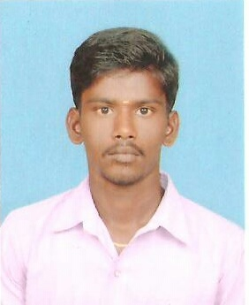 **A.KARTHI**

**Email ID: akarthi436@ gmail.com**

**CONTACT NO:7695921011.**

**CARRIER OBJECTIVE**:

To seek challenging assignment and responsibility, with an opportunity for growth and carrier advancement as successful achievements.

**EDUCATIONAL QUALIFICATION**:

|  |  |  |  |  |
| --- | --- | --- | --- | --- |
| **Qualification** | **Year** | **College/School** | **Board/University** | **Result** |
| B.E / EEE | 2013-2017 | Sri Raaja Raajan College of Engineering &Tech, Karaikudi. | Anna university  Chennai | 6.5 (CGPA)  Pursuing |
| HSC | 2013 | Sirumalar Higher Secondary School,  Andavoorani. | State | 67.58% |
| SSLC | 2011 | Subramanian Chettiar Gurukulam Higher Secondary School, Amaravathipudur. | State | 79.2% |

**AREA OF INTEREST**:

* Power Electronics Switches, Power plants.

**INPLANT TRAINING:**

* I have attended In plant training on PLC in TVS Chennai.
* I got various workshop training during the college period.
* I did many mini projects in my college period

**COMPUTER SKILLS**:

|  |  |
| --- | --- |
| Programs | PLC,SCADA |
| Software’s | C,C++, |

**PROFESSIONAL TRAITS:**

* Willingness to work in team and hard worker.
* Disciplined & good etiquette.
* Easily adaptable to new environment.

**ACHIEVEMENTS:**

* Won certificate for MINI PROJECT on SRRCET.
* I am the member of ROTARY CLUB in our college.

**PROJECT:**

**Maximum Power Point Tracking Control of Solar Power Generation Systems**

**BIO DATA:**

|  |  |
| --- | --- |
| **Father's Name** | : ARIYAMUTHU A |
| **Date of Birth** | : 21.01.1996 |
| **Gender** | : Male |
| **Marital Status** | : Single |
| **Nationality** | : Indian |
| **Permanent Address** | :3/140, Ramalingapuram,  Karumal (po),  Ramanathapuram (dist)-623711 |
| **Language Known** | :Tamil, English |

**DECLARATION:**

I hereby declare that the above-mentioned information is correct up to my knowledge and I bear the responsibility for the correctness of the above-mentioned particulars.

**Date :   01/04/2017                                                                                                    Signature**

**Place : Karaikudi    (A.KARTHI)**