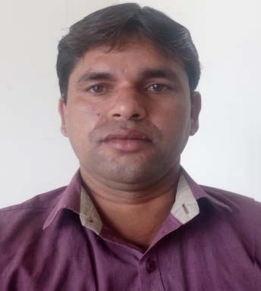

**TAHSEEL KHAN**

**PERSONAL INFORMATION**

**PERMANENT ADDRESS**:

*Village Chirchita Post‐ Mukimpur Disst‐ Bulandshahr*

*Uttarpradesh‐ 203001*

***CONTACT ADDRESS:***

*Village Asgarpur Sector‐128 Noida‐201304 Uttarpardesh*

**PHONE *:*** +91-9891095402

***E-*MAIL*:*** [sahil.erac@gmail.com](mailto:sahil.erac@gmail.com)

**Gender**: Male

**Nationality:**

Indian

**Date Of Birth:**

05/03/1980

**Marital Status:**

Married

**Father’s Name** : Baseer Khan

**Languages Known:**

Urdu. Hindi. English.

**Interests and Hobbies:**

Sports Listing Music

Gaining Technical Knowledge

**RESUME**

**Career Objective**

To be an accomplished professional and use effectively all my skills to the best of my ability and intelligence and contribute to the growth of the organization. I will never be a liability to my company.

**Work Experience**

# JAIPRAKASH ASSOCIATES Pvt. Ltd.

Having more than 8 years of experience as technical client support in Facility management services.

**Professional Qualifications**

* Maintaining SAP Module for stores and generate all MIS reports.
* Monthly consumption report, rejection report & maintain minimum order level through SAP entries.
* Supervising/Monitoring with feedback of electrical staff and coordination the daily activities of the electrical department.
* Managing timesheets and leave system of staff with proper entries.
* Carrying out inspections on all plant electrical equipment.
* Developing relationships with external suppliers.
* Material receipt from main stores & supply of material to the department i.e. civil, mechanical, electrical & plumbing.
* Total stores function, Receipt & Issue including Documentation of stores related work.
* Negotiating with clients to prepare project specifications.

•

**Professional skill**

* Handling SAP modules for store department.
* Technical client support for problem solving
* Electrical and other house hold support to clients.
* Procurement of item from store department and allocate them as per the requirement.
* CC TV installation and maintaining DVR , finding the location and communication with vendor.
* IT supports to back office with user support and technical help in hardware and networking.
* Guiding staff for the installation of electrical equipments and Air‐ conditioner.
* Maintaining Inventory Management system for stores.

***Operating Systems:***

Handling Hardware. working on MS-Office. Networking operation. Working on SAP software. Troubleshooting operating

systems.

***Skill:***

Client Communication. Hardware & Networking. Multi-Tasking Work Skill. Air-Conditioning installation.

Telecommunication Knowledge.

**Academic Qualifications**

* Diploma in Electrical in 2009 through

## JRN Rajesthan Vidyapeeth University.

* Diploma in Computer in 2008 through

## Techno Sphere Computer Education Center.

* ITI in Electronics in 1999 through

## Govt. I.T.I.,Sahkari Nagar, Bulandshahr.

* Diploma in Radio, Television Technology in 1998 through

## National Institute Of Technology

* Passed Inter Mediate From

## GK Inter Coll Khera Dnagar.Aligarh. (UP Board)

* Passed High School From

## Jatpura Inters College Bulandshahr. (UP Board)

**Technical Knowledge**

Good theoretical and technical knowledge of:

* Troubleshooting of windows operating systems
* Managing SAP entries.
* Managing CCTV Camera systems.
* Managing FFTH network systems.
* Design LAN, Punching I/O laying cables.
* Configuring of network client workstation.
* Troubleshooting of LAN connectivity issues, software & Hardware.

**I hereby declare that all above mentioned information are true up to the best of my Knowledge.**

# TAHSEEL KHAN