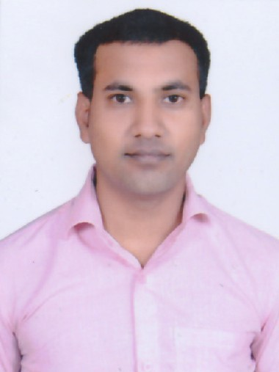**SHOIEB ALI**

181 fakruddin ali Ahmed Nagar kanch ka pull meerut 250002

[shoiebali368@gmail.com](mailto:shoiebali368@gmail.com) Mobile :+917017789274

# Career Objective :

Get hold of a position that will give me the ability to relate my sales education to a growing industry. Look forward to working with a corporation that promotes superior products and services; and give me with the chance to meet and go beyond assigned sales goals.

# Academic Details :

* BCA [2012] with aggregate of 74% from MIT MEERUT
* 12th [2009] with aggregate of 57% from UP BOARD
* 10th [2007] with aggregate of 45% from UP BOARD

# Work Experience :

* Worked as Team mamber in Pizza hut from Jul 2011 to May 2013 Role :as a working team mamber
* Worked as assistant team leader in BPO from Jul 2013 to Sep 2016 Role :as a working sales and retantion assistant team leader
* Worked as Sales person in Sales Retail from Jul 2016 to Jun 2018 Role :as a working sales person in retail

# Field of Interests :

* Sales
* Cashier
* Computer data operator
* Custumer retantion
* Restaurants

# Skills :

* Customer service skill
* Retantion skill
* Sales skill

# Strength & Hobbies :

* Team and alone work
* Positive confident
* Listen music
* Surfing internet
* Watch the movie

# Declaration :

I hereby declare that the above-mentioned information is correct up to my knowledge and I bear the responsibility for the correctness of the above-mentioned particulars.

Date : ( )

Place : Meerut

(SHOIEB ALI)