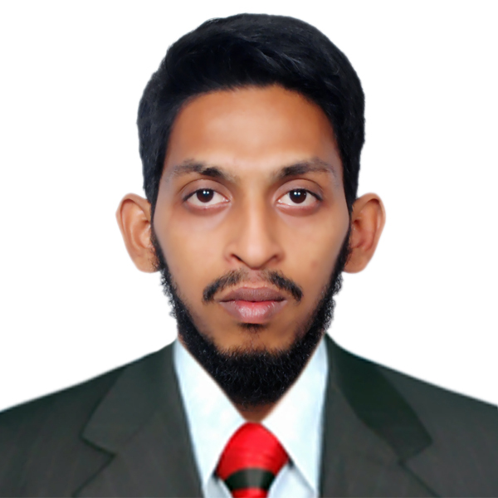**MOHAMMED ABDUL KHAYOOM**

Mobile: +91-8099914812

E-Mail: [mohd.abdulkhayoom786@gmail.co](mailto:mohd.abdulkhayoom786@gmail.co)m

# **OBJECTIVE** : To work hard with full dedication for the achievement of organization objective under satisfying job contact, hence enhancing my skill and knowledge and ready to learn new things.

**EDUCATION:**

|  |  |  |
| --- | --- | --- |
| **DEGREE** | **UNIVERSITY/COLLEGE** | **YEAR** |
| Graduation –B-tech (EEE) | VISHWA BHARATHI COLLEGE OF ENGINEERING | 2010-2014 |
| Intermediate- MPC | Sri Chaitanya Jr. Kalasala | 2008-2010 |
| CBSE | Kendriya Vidyalaya(OFPM) | 1998-2008 |

**PROJECT REPORT**:

1. PROJECT TITLE: Modeling and Simulation of Matrix Converter Based DC-DC Converter

PROJECT DESCRIPTION: The modeling and simulation of DC-DC converter with matrix converter as its basic topology. DC- DC converters are frequently utilized in traction motor speed control and switched mode power supply. Control of speed of dc motor is specially required where supply is dc voltage Matrix converter does not have energy storage components as compared to conventional converters which use energy storage components.. In this paper, DC-DC converter is proposed to generate a variable dc voltage from a fixed dc voltage using single phase matrix converter topology that has been used in direct AC-AC converter application. State space modeling is developed taking currents as state variables. But using inductance in load generates some distortions in output of converter. As frequency is increased distortions in the output of the converter get reduced for inductive load. The DC-DC converter is based on four quadrant operation of chopper and the output of converter is synthesized by using PWM technique.

1. PROJECT TITLE:GSM BASED STEPPER MOTOR SPEED CONTROL

PROJECT DESCRIPTION: The goal of the project is to develop a system, which uses Mobile technology that keeps control of STEPPER MOTORS in different applications, which executes with respect to the signal sent by the mobile. For utilization of appliances the new concept has been thought to manage them remotely by using mobile, which enables the user to remotely switching and controlling of STEPPER motor using PWM (Pulse Width Modulation) technique. Just by dialing keypad of remote telephone, from where you are calling you can perform ON / OFF and at the same time we can control the speed of Stepper motor operation. The ranges of appliances that can be controlled through tele remote systems are many in numbers. Some of them are as follows and this depends upon the usage priority of the appliances i.e. parking Lights, Music System or other electrical / electronic appliances.

**WORK EXPERIENCE:**

### 1)ArkEN Solutions, (February- 2017-till date)

#### Responsibilities

**Electrical Engineer in solar plant (33/132kv)**

1. Installation of LT, HT, Scada Panels, Inverters, UPS, SMB, PV Modules, Transformers, Fire Alarms , Cctv.
2. Erection of switchyard.
3. Testing (IR , Vector Group Test, oil filtration test, Continuity Test, Hipot test)
4. Commissioning
5. Basic Scada operations

### 2)SP ELECTRICALS, 1.8years (18 November 2014 to 14 July 2016)

#### Responsibilities

**Electrical Engineer Trainee**

1. Installing motor-control devices, switch panels, transformers, control panels.
2. Diagnose cause of electrical or mechanical malfunction.
3. Replacing equipments which fail to meet acceptable operating standards.

### 3) ORDNANCE FACTORY, for two months.

#### Responsibilities

### Inplant trainee.

1. Operation and Maintenance of 132 KV main receiving station.
2. 33/0.433KV Distribution substation and Electrical maintenance of Industrial Buildings.
3. Testing of switchgear protection

**TECHNICAL SKILLS**:

* **Computer languages**: C,MATLAB,AUTOCAD
* **Operating system** : Windows XP, Windows 7, Windows 8
* **Office Tool** : Microsoft Office (Word, Excel, PowerPoint)

**ACHEIVEMENTS:**

1. Achieved silver medal in football from Hyderabad region.
2. Participated as an athletic runner for Hyderabad region from Kendriya Vidyalaya School.
3. Achieved first prize in quiz competition in SPARX 2012
4. Achieved 6 bands in IELTS speaking and overall 5.5 bands.
5. Power Medicine and First Aid certificate from St. John Ambulance Association .

**STRENGTHS** :

1. Quick learner.
2. Team player
3. Leadership Qualities
4. Adaptable.

**PERSONAL INFORMATION:**

Address : LAHARI JADE RESIDENZA, PATANCHERU, TELANGANA, INDIA

Date of birth : 24-09-1992

Languages known : ENGLISH, HINDI, TELUGU, URDU.

Passport number : M0562251

Date of issue : 30/07/2014

Date of expiry : 29/07/2024

**DECLRATION:**

Ihereby declare that the above written particulars are true and correct to the best of my knowledge and belief.

**MD ABDUL KHAYOOM**