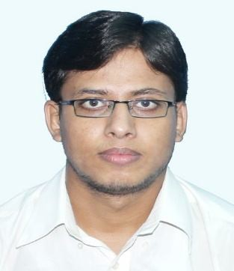*CURRICULUM VITAE*

**UMA SHANKAR SHARMA**

CONTACT NO: **08653673771**

EMAIL ID**-** [**ussharma192@gmail.com**](mailto:ussharma192@gmail.com)

Seeking a challenging career with a reputed and progressive organization that will allow me to utilize and enhance my skills, abilities and education while contributing to organizational goals.

**CARRIER OBJECTIVE**

* **TECHNICAL**

**EDUCATIONAL QUALIFICATIONS**

|  |  |  |
| --- | --- | --- |
| **STREAM** | **COLLEGE** | **UNIVERSITY** |
| **ELECTRICAL ENGINEERING**  (**2011-2015**) | **Kanad Institute Of Engineering And Management.**  **Durgapur(WB)** | **West Bengal University of Technology** |

* + **DETAILS:**

|  |  |  |  |  |  |  |  |  |  |
| --- | --- | --- | --- | --- | --- | --- | --- | --- | --- |
| **Semester** | **1st** | **2nd** | **3rd** | **4th** | **5th** | **6th** | **7th** | **8th** | **DGPA** |
| **SGPA** | **7.89** | **7.40** | **7.37** | **7.61** | **7.93** | **8.18** | **8.81** | **-** | **-** |
| **YGPA** | **7.65** | | **7.49** | | **8.05** | | **-** | |

* **Non-Technical**

|  |  |  |  |  |
| --- | --- | --- | --- | --- |
| **EXAMINATIONS** | **SCHOOL** | **BOARD** | **YEAR** | **MARKS (%)** |
| SECONDARY | G N HIGH SCHOOL KOTHIYA | BSEB | 2009 | **58.5%** |
| HIGHER SECONDARY | M B D COLLEGE RAMPURA DARBHANGA | BSEB | 2011 | **54.2%** |

**TRAINING**

* *Have Completed One Month’s Training in* **“ELECTRIC LOCO SHED (TRS)/EASTERN RAILWAY, ASANSOL”** *of 4 weeks (from 25th OCTOBER to 24th NOVEMBER 2013).*
* *Have completed the vocational training in* ***“DSTPS (DVC, Andal )’’*** *of 3 weeks(from 3rd to 18th JANUARY 2014).*
* *Advance plc. in* **“*INDO DANISH TOOL ROOM Gamharia , Jamshedpur-832108*”** *of one month (1st to 31st JULY 2014).*
* Comprehensive problem solving abilities.

**PERSONAL SKILLS**

* Ability to deal with people diplomatically.
* **Willingness to learn and hard working.** . P.T.O

**SUBJECTS OF INTEREST**

* **POWER SYSTEM.**
* **ELECTRICAL MACHINE.**
* **CONTROL SYSTEM.**

**COMPUTER SKILLS**

* **Platforms** : XP, windows7, windows8.
* **Applications** : Plc. Scada, MS Word, Power point, Excel.
* **Languages Known** : Elementary Knowledge in MATLAB.

# Committee member & cashier in college program.

**EXTRA ACTIVITYS**

* + **Anti-ragging member in college.**

**HOBBIES**

* **Listening music.**

## PERMANENT ADDRESS

UMA SHANKAR SHARMA, S/O- LAL BAHADUR SHARMA, VILL- PATTITOLA

P.S. – Bherabsthan, P.O.- Kothiya, DIST. – Madhubani,

STATE-Bihar, PIN CODE-847404

## PERSONAL DETAIL

* Father’s name - LAL BAHADUR SHARMA
* Gender - Male.
* Marital status - Unmarried.
* Nationality - Indian.
* Date of Birth - 28/12/1994.
* Languages - English, Hindi, Bangla, Maithili.

## DECLARATION

I hereby declare that the above-mentioned information is correct to the best of my knowledge and I bear the responsibility for the correctness of the above-mentioned particular.

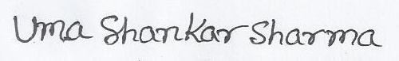DATE:

SIGNATURE