

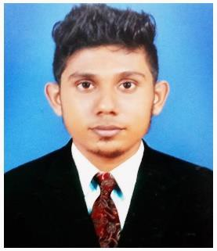**Sheikh Sharoon**

Ahmed Nagar, Post Pejavara, Via Bajpe, Mangalore-574142

|  |  |
| --- | --- |
| Contact No:8147747576 | Email [Id:sheikhsharoon@gmail.com](mailto:sheikhsharoon@gmail.com) |

# OBJECTIVE

To work for a competitive and dynamic organisation by applying the gained Engineering skills and leadership qualities, with professional growth.

# ACADEMIC QUALIFICATIONS

|  |  |  |  |  |
| --- | --- | --- | --- | --- |
| **Qualification** | **Institution** | **University/Board** | **Year of passing** | **Aggregate %** |
| BE(ECE) | St. Joseph Engineering College, Vamanjoor,  Mangalore | Visvesvaraya Technological University | 2017 | 73.26% |
| II PUC | St. Aloysius Pre-University  College, Kodialbail, Mangalore | Karnataka State Board | 2013 | 90% |
| SSLC | Ansar English Medium School  Bajpe, Mangalore | SSLC board | 2011 | 88.48% |

**PROJECTS**

* **Over Speed Detector (Mini project)**: Used to control the speed of vehicles. College: St. Joseph Engineering College, Vamanjoor, Mangalore.

Duration: 3 days

* **Electronics dice (Mini project)**: Electronic version of normal dice. College: St. Joseph Engineering College, Vamanjoor, Mangalore. Duration: 2 days
* **Farm Bot (Main project):** Farming robot

College: St. Joseph Engineering College, Vamanjoor, Mangalore.

# TECHNICAL SKILLS



* **Programming skills** : Basic knowledge of C, Verilog, HDL.
* **Software Tool** : Matlab, Multisim, Fritzing, Microsoft Office Word,

Microsoft Office power point, Keil Software, Xilinx, Cadence, Proteus.

* **Hardware** : Circuit design, 8086 Micro Processor, 8051 Micro Controller.
* **Operating System** : Windows, Linux.

**COMPETENCIES**

* Good team player.
* Good command over language.
* Effective time management capability.
* Ability to guide and lead a team setting.
* Ability to work hard and learn new skills.

# PERSONAL DETAILS

* **Date of Birth** : 24th June 1995.
* **Languages known** : English, Kannada, Hindi.
* **Nationality** : Indian.
* **Hobbies** : Playing Cricket and Badminton, Singing, Playing Video

Games.

# DECLARATION

I hereby declare that the Information furnished above is true and correct to the best of my knowledge.

|  |  |
| --- | --- |
| **Date: 1st August 2017 Place: Mangalore** | **Signature:** |