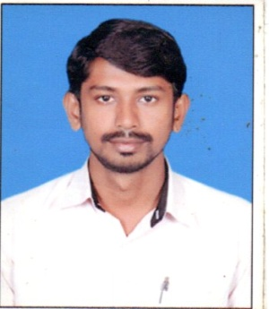

**MOHAMED SATHIK.A**

**Email Id:** mohamedsathik**.**cvl@gmail**.**com

**Mobile No: +91 98848 75590 , +91 95979 56277**

### Executive Summary

* Currently associating with **Perfect Builders as a Project Engineer.**

### DOMAIN SKILLS

* Self-directed and highly-motivated.
* Able to work in a fast-paced and deadline-driven environment.
* Detail-oriented, dependable and trustworthy.

### CAREER RECTICAL

1. **Project Engineer** (May 2011 to Till date)

**Perfect Builders**

**Key role and responsibilities:**

* Setting out the works in accordance with the drawings and specification.
* Liaising with the project planning engineer regarding construction programmes.
* Checking materials and work in progress for compliance with the specified requirements
* Observance of safety requirements
* Resolving technical issues with employer’s representatives, suppliers, subcontractors and statutory authorities
* Quality control in accordance with CSIs/procedures method statements, quality plans and inspection and test plans, all prepared by the project management team and by subcontractors
* Supervising and counselling junior or trainee engineers
* Measurement and valuation (in collaboration with the project quantity surveyor where appropriate)
* Providing data in respect of variation orders and site instructions
* Preparing record drawings, technical reports, site diary
* Job review of subordinate staff

|  |
| --- |
|  |

### Academics Profile

1. Course : **Bachelor of Engineering in Civil**

Institution : Sun College of Engineering & Technology

University : Anna University, India

Academic Year : 2007 – 2011

## Computer skills

* Autocad 2010
* Computer Basic, OS Windows XP, Vista & 2007.
* Microsoft Office 2003, XP, 2007.

### Personal Attributes

* Excellent communication capabilities and flexible in type to interact with others and computer literacy.
* Have an aggressive growth attitude and willingness to identity and take calculated risk.
* Reliable and well organized.
* Ability to Organize and motivate a team work equally well within one.
* Awareness about personal safety rules and regulations.

### Project

PEREFECT BUILDERS PVT LTD, CHENNAI MAY’11 till date

As Project engineer

* Managing 12 project employees, including in-house, external contractors and sub contractors; attending meeting discussing project details with clients, contractors and stake holders
* Perform drafting according to specifications; ensured compliance with all project QA procedures and requirements
* Preparing monthly reports detailing progress on engineering, procurement, marketing & commissioning activities
* Conducting delay analysis and risk analysis as part of the project release process
* Successfully completed the residential projects in Chennai worth INR 25 crores

### Personal information

Father’s name : S M Y ABDUL KADER

Permanent Address: 63, Periya kothuba palli vasal south west street, Melapalayam, Tirunelveli, TN.

Date of Birth : 05.05.1990

Nationality : Indian

Gender : Male

Marital Status : Married

Passport Number : J 0614078

Passport Expiry Date: MAY 2020

Languages Known : English (Read, Write and Speak)

Tamil (Read, Write and Speak)

### Declaration

I, the undersigned, certify that to the best of my knowledge and belief, these CVs correctly describe my qualifications, my Experience and me.

Place:

Date: