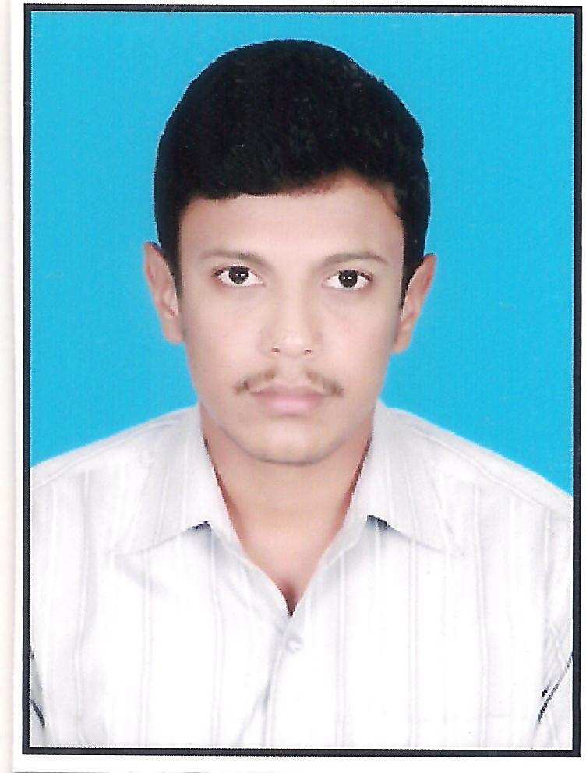**CURRICULUM VITAE**

MAHESWARAMUNIRAJ.V

Contact no: +91 8760999856

E-Mail: [mvmakesh04@gmail.com](mailto:mvmakesh04@gmail.com) Skype id: maheshmvr4

# OBJECTIVE:

To work in a professional environment that will exercise fullest of my knowledge and give me ample opportunity to learn most of the evolving technologies and thus ensuring mutual growth.

# ACADEMIC QUALIFICATIONS:

|  |  |  |  |  |
| --- | --- | --- | --- | --- |
| **Course/ Year of passing** | **Department** | **Name of Institution** | **University / Board** | **Percentage / CGPA** |
| M.E  (June 2016) | Communication Systems | RVS College of Engineering & Technology, Coimbatore. India | Anna  University, Chennai. India | 61 |
| B.E  (May 2012) | Electronics & Communication Engineering | VMKV Engineering College, Salem. India | Vinayaka Missions University, Salem.  India | 60 |
| D.E.C.E  (April 2009) | Electronics & Communication Engineering | Thiru Ramakrishna Nallammai Polytechnic College, Dharapuram,  India | Directorate Of Technical Education.  Chennai, India | 64 |

**AREA OF INTEREST:**

1. Fiber optical Installation
2. Wireless Communication
3. Long Term Evolution
4. Microwave Transmission
5. GSM, WCDMA & 3GPP
6. RF Optimization
7. Telecommunication & Networking
8. System Troubleshooting
9. Good knowledge in Electronic components & Chip

# CARRIER HIGHLIGHTS:

1. Fiber rectification through OTDR from both ends.
2. Supervise Fiber Optic Installation works and restore interrupted existing external fiber optic network in minimum set time,
3. Material planning i.e., Monthly requirement, Dispatch instruction, Timely availability of material at sites.
4. Quality control of Outside Plant Cable Networks.
5. Project management/Material management.
6. Planning and implementation of OSP Project.
7. Making of daily, weekly and monthly MIS reports.
8. Installation of ONT (Optical Network Terminal).
9. Knowledge in FTTH Connection,
10. Cable routing & fixing, Whether proofing of RF cable end to end.
11. Splicing and patching of optical fiber.
12. Execution of Fiber Optic External Network Installation & Maintenance works includes fiber splicing and labeling.

# WORKING EXPERIENCE:

* Worked as a TRAINEE ENGINEER as a Tele-Communication Engineer at Kutumbh Care, Noida, U.P, India, in the period of 8 June 2016 – 13 October 2017.

# SOFTWARE SKILLS:

Package : C, Matlab, Embedded System, PCB Layout Platform : Windows, MS Office, MS Excel, Power Point,

# PERSONAL DETAILS:

Name : V.Maheswaramuniraj Father’s Name : M.Varatharajan Gender : Male

Date of Birth : 13.05.1989

Languages Known : English, Tamil and Telugu. Passport Number : M6685359

Nationality : Indian

Marital Status : Single

Address : 260-A, Cholakkadai Street, Dharapuram – 638 656.

Tiruppur Dist, Tamil Nadu, India.

# DECLARATION:

I do hereby declare that the details furnished above are true to the best of my knowledge.

Yours Sincerely,

Place:

Date: (V.MAHESWARAMUNIRAJ)