CURRICULUM VITAE

Email.asim.hasan567@gmail.com 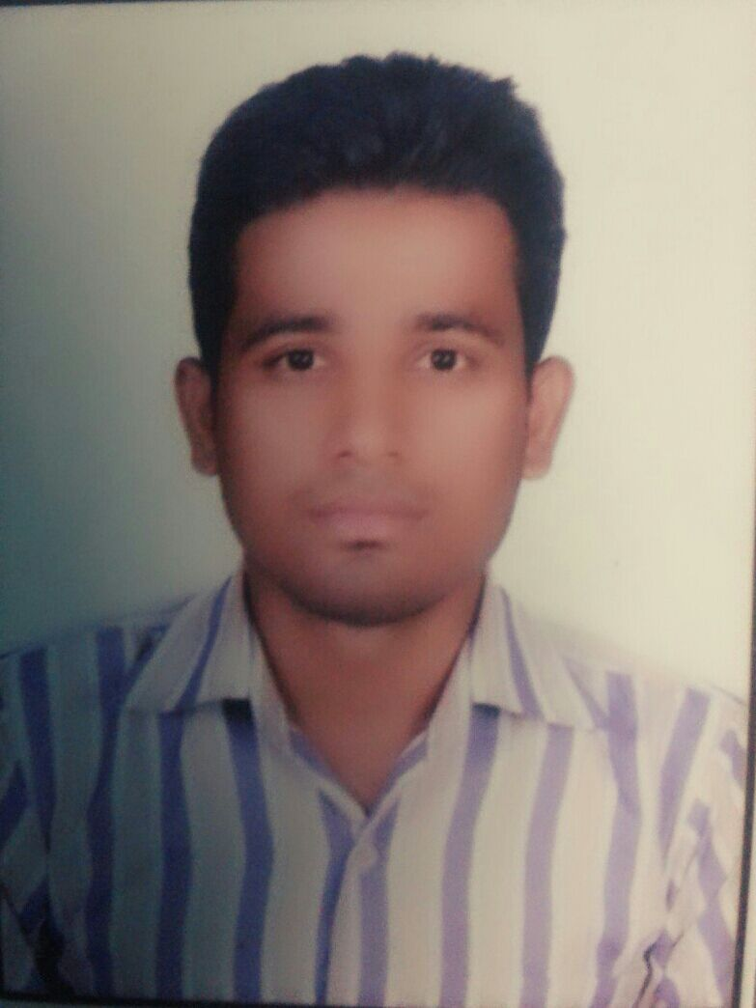

Mob.+918853396126,INDIA

Mob.+971543964037,UAE **Name : Asim Hasan Khan**  **Designation,Electrical Technician**

Countries of Experience : India, UAE(Abudhabi Technical Qualification : ITI,(2Years ) Total Experience : 07 Years

(SCVT,Shahjahanpur)

**1. SITE : ADCO & GASCO ,ABUDHABI,UAE**

Project : Habshan&Bab(PGUR,5283) Oil&Gas Petroleum,Onshore

Client : Emiratess Technical Associatess LLC

: Power Project Division,Abudhabi,UAE

Duration :26,12,2015 to 17,5,2017

**Experience in Testing & Commissioning Team:**

1. Wiring Modification works for 220/132kv Transformer with GIS

2. Wiring Modification works for132/33kv Transformer with GIS

3. Wiring Modification works for 33/11kv Transformer with GIS

4. Wiring Modification works for 11kv/ 415V Transformer with AIS

5. Arranging Testing kits and making setup

6. Transformer testing arrangement works

7. Worked in Switchgears, Transformer and cable Testing

8. Making connections for Testing DB

9. Testing of control cable and LV power cable IR Measurement(Megger)

10. Working battry all system and UPS

11. Working with siemens, schneider electric and ABB vendors

**Construction Team:**

1. Termination of control cables as per termination schedule

2. Laying the cables as per cable schedule also tagging and dressing

3. Working in 33KV power cable laying and termination

4. Battery cable termination works

5. WorkingF&G control panel termination per cable schedule

##### 2 . SITE : TRANSCO,ABUDHABI,UAE

Project : Electrical substation 220/33 kv (N7277,ALAIN,UAE)

Client : Emiratess Technical Associatess LLC.

: Power Project Division,Abudhabi ,UAE

**Duration : 06,15,2015 to 12,25,2015**

#### 

**Experianced construction;**

1. Single phase and three phase Motor connection works

2. Busbar tightness and torque checking

3. 33KV- 300sqmm cable glanding, laying & termination

4. control cable laying, termination and Testing IR(insulaion resistance) each (core to earth)

and (core to core)

5. Motor control box connetions (push bottun, emergency switch,selector switch and lamps)

6. Substation Tube light, sockets and switches termination works

7. Work industries type 220/kv substation in /oil&gas petrolium/&chemicals plant

8. Maintenance& shutdown& project in oil&gas petroleum plant onshore

9. Inspect electrical component such as transformers and circuit breaker

10. Identify electrical problems with variefy of testing device

#### Domestic Assignmente

1. **SITE : BUILDING,CONSTRUCTION,IN,INDIA**

Client : Mahfooz Hussain Con.(Shahjahanpur)

Duration : From 24.04.2010 to 15.11.2015

**Construction Teame ;**

#### 1. Tray work, PVC, SS, MS Conduit work.

#### 2. Consild wiring, Clit wiring, casing- capping wiring work.

#### 3. Building Electrical all kinds of work , Maintenance

#### 4. Experience in erection of Switchgear and Panel.

#### 5. Control cable laying and termination work.

#### 6. Indoor and Outdoor Earthing work.

#### 7. 132KV GIS and 11KV SWGR Commissioning work.

#### 8. Worked in Shutdown jobs

#### 9. Worked with Testing and Commissioning team

#### 

**Designation; Maintenance**

1, Single and Three phase motor winding repairing and fixing work.

2, Selling fan, iron, Cooler, Table fan, Mixer, Grinder winding and repairing work.

3, All type of House wiring and maintenance work.

4, Tray work, PVC, SS, MS Conduit work.

5, Consild wiring, Clit wiring, casing- capping wiring work.

6, Building Electrical all kinds of work , Maintenance and contraction rework

**PERSONAL PROFILE**

Father name : Matloob Hasan Khan

Date of Birth : 08.09.1993

Sex : Male

Religion : Muslim

Marital Status : Single

Nationality : Indian

Passport No : L3700025

Computer skills : MS WORD

Languages Known : Hindi, Urdu, & English

Industries type : Elec Substation in Oil&Gas petroleum and Building

College of study : INDUSTRIAL TRAINING INSTITUITE ,BAREILLY ,INDIA

Field of Experience : Elec Technician (Testing,Construction, and Maintenance)

Permananet Adress : H.no.137,moh. Rangeen Chaupal,Dist,Shahjahanpur

Pin Code.242001./ Uttar pardesh,India

Current Adress : Emiratess Technical Associatess llc (Abudhabi,UAE)

1.Declaration

I hereby declare that all above-mentioned information is correct up to my knowledge and bear the responsibility for the correctness of the above-mentioned particulars.

Date:

Sign:

Regard

Asim Hasan Khan