***RESUME***

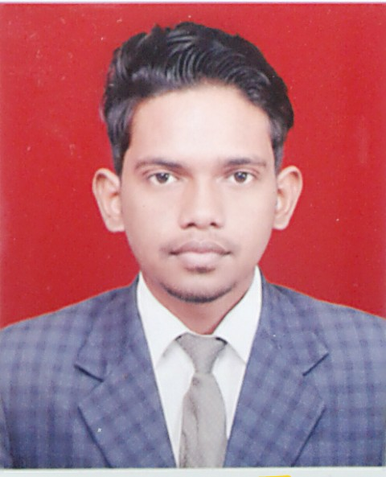*MOHAMMAD SHARIK*

*Contact: +91-9627689954*

*E-Mail:* [*sharikmohammad111@gmail.com*](mailto:sharikmohammad111@gmail.com)***CAREER OBJ ECTIVE -***

*I want to grow my ca****r*** *ier in good environment company, where I can prove myself and enable*

*and enhance my working skills.* ***EDUCATIONAL QUALIFICATION -***

***:-*** *B.Com from MJ P Rohilkhand University Bareilly, U.P. (2016)*

*:- Senior Secondory from U.P Bord ( 2013)*

*:- Higher Secondory from U.P Bord (2010)*

# *TECHNICAL QUALIFICATION -*

*:- Advance Diploma In Computer Applications (ADCA)*

*:- Basic knowledge of computerapplications.*

*:- Tally 9.0./ M S Word./ Internet.*

*:- Certificate of Cource On Computer Concept (CCC) from NIELIT (New Delhi)*

# *EXTERNAL QUALIFICATION -*

*:- English Typing 35 WPM.*

# *PERSONAL DETAILS -*

*:-Father’s Name : - Mr. Mohd Shabbir*

*:-Address :- City- Bareilly,U.P. State in India*

*:-Date of Birth : - 14 - 03 -1994*

*:-Marital Status : - Single*

*:-Languages Known : - English, Hindi & Urdu* ***PASSPORT DETAILS-***

*:- Passport No.* ***:- M9126595***

*:- Nationality :- INDIAN*

*:- Place of Issue :- BAREILLY*

*:- Date of Issue :- 22/ 05/ 2015*

*:- Date of Expiry :- 21/ 05/ 2025* ***HOBBIES -***

*:- Watching news channels & Lestining Music MOHAMMAD SHARIK*