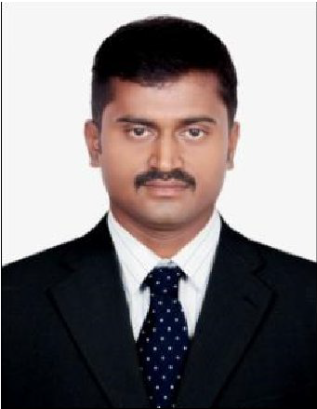

**India,odisha**

**Mobile Phone +917064265516** [**thebiswajit@ymail.com**](mailto:thebiswajit@ymail.com)

***BISWAJIT BEHERA***

**PERSONAL IDENTITY**

Name : BISWAJIT BEHERA

Sex : male

Place/Date of Birth : India/ June10, 1988 Religion : Hindu

Marital Status : Married

Address : Nuagaongram, Sailogovindpur, Cuttack, (Odisha).

# EDUCATIONAL BACKGROUND

|  |  |  |
| --- | --- | --- |
|  | D.E | : Diploma in Electrical Engineering,IIMSR, NEWDELHI. |
|  | I.T.I | **: I T I from GIET, Bhubaneswar, Odisha.** |
|  | C.H.S.E | : +2 (ARTS ) From board of odisha. |
|  | H.S.C. | :Secondary School Certificate from Board of Secondary FROM ORISSA. |

**COMPUTER KNOWLEDGE**

* Operating System : Windows XP/2000/98/7,.
* Internet Surfing E-mail Checking etc.

.P.G.D.C.A.- : From CITYCOMPUTER ORISSA

# TECHNICAL PROFILE

* I.T.I. from G.I.E.T. Bhubaneswar Odisha.
* Diploma in electrical engineering from IIMSR, NEW DELHI .

**PRESENT EXPERIENCE:**

Presently Working as an **Electrical supervisor** in Reputed **ISO 9000-2000, OHSAS-18001**

Company **TRINITY ENGINEERING SERVICES WLL.** - **Qatar**

Present Project Execution:- Abraj quartier-3,4 in pearl qatar.

Clienrt : Medad,qatar

# Previous completed project in EMCO.

* Project :Electrical worksfor the Implementation of 4MWNGK Battery Energy Storage(42MW).

Client :Addc, abu dhabi..uae.

Project duration : Dec 2014 to march 2016..

* Project : EPC for 350 accommodation for contractor staff at Asab.

Client : Abudhabi Gas Industries co (GASCO) Project duration : Feb 2014 to dec 2014.

* Project :EPC For New Asab Accommodation Complex Phase-III Client : Abudhabi Gas Industries co (GASCO)

Project duration : Aus 2012 to Jan2014

**JOB & RESPONSIBILITY**

Supervised the execution of electrical works in construction project sites.

Developed work schedule for building construction projects Schedule of material deliveries at site and manpower.

Prepared Shop Drawings coordinate with Foreman & Technician

Installation of Medium voltage, Low current, Low voltage system Etc. Prepared Request for inspections Enforce Health, Safety and Environmental policies of the company in construction projects.

Sourced out materials for electrical works in building construction projects.

1. Conduiting work.-Gi,Pvc.
2. Wiring. control wiring.
3. Cable tray,trunking,ladder work.
4. cable pulling,dressing,glanding,termination. 5.Panell instalation.
5. Earthing systeam.
6. Hv ,lv cable glanding.
7. Bus duct installation.

# PREVIOUS EXPERIENCE

* Working as **ELECTRICAL SUPERVISOR**in FALCON TOWER

Employer : **ETA Engineering & Contracting W.L.L (M&E Division) Doha, Qatar**. Main Contractor : **s.e.g. qatar**

* JAIDAHA TOWER: Worked as **electrical supervisor**from October 2009 to October2011.

# Employer: ETA Engineering & Contracting W.L.L (M&E Division) Doha, Qatar. Main Contractor: BROKEFIELD MULTIPLEX MEDGULF,Qatar WLL

Client ; **JAIDAHA INVESTMENT AND REALESTATE DEVELOPMENT CO.**

* DUBAITOWER PROJECT, QATARfrom October 2008 to october2009.

Employer**: ETA Engineering & Contracting W.L.L (M&E Division) Doha, Qatar**. Main Contractor : **ALJABERALHABTOOR,QATAR**

Client : **SAMADUBAI**

**Behavioral Characteristics**

* Commitment to quality and results
* Responsibility
* Sincere in attitude
* Problem Solving Skills

# Competencies:

* Fast learner, adapts well to changes.
* Friendly with an upbeat attitude.
* Hardworking and committed to excellence

# Hobbies & Interests:

* Music, Reading, Games

# PASSPORT DETAILS

* Passport No. : **G6514752**
* Date of Issue : **20-3-2008**
* Date of Expiry : **19-3-2018**
* Place of Issue :**BHUBANESWAR, INDIA**

# DECLARATION

* I hereby declare that all the details given above are true to the best of my knowledge and belief.

*(BISWAJIT BEHERA)*