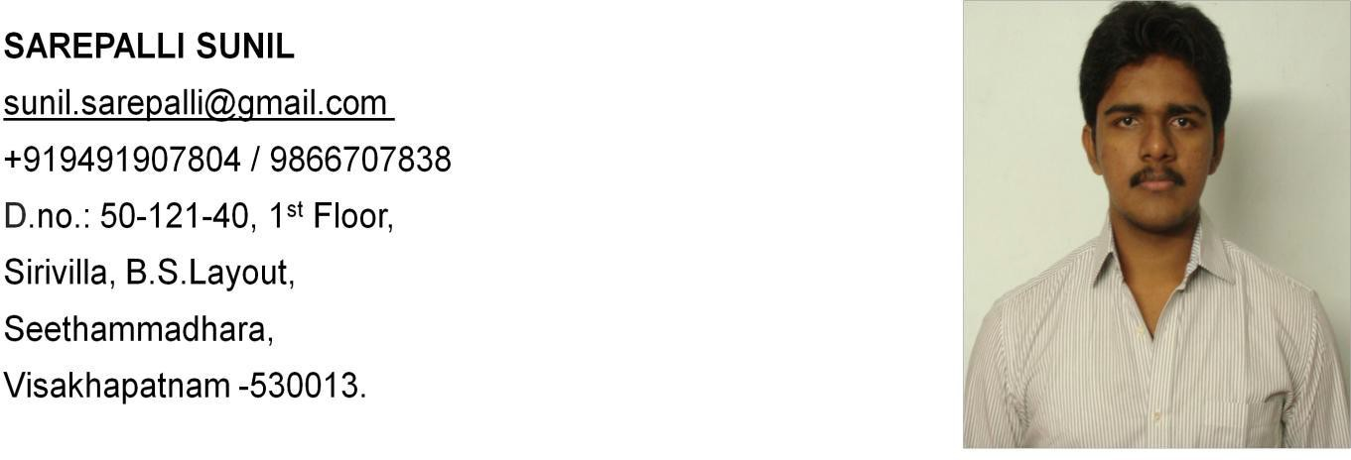

# Career Objective:

To gain and to explore the knowledge and skills for the development of the organization, I work and myself

**Date of Birth:** 5th July, 1990

# Academic Qualifications:

|  |  |  |  |  |
| --- | --- | --- | --- | --- |
| Qualification | Institution, Place | Board, | Year of | Percentage of |
| University | passing | Marks |
| B.Tech. | M.V.G.R. College of | J.N.T.U. | 2012 | 77.48% |
| (EEE) | Engineering, | Kakinada |
|  | Vizianagaram |  |
| Intermediate | Sri Chaitanya Junior | B.I.E.A.P. | 2008 | 91.3% |
| College, Visakhapatnam |
| 10thclass | P.E.N. High School, | S.S.C. | 2006 | 86.67% |
| Visakhapatnam |

**Experience:**

* Working as an “**Electrical Engineer**” in **Jyoti Bio Energy Limited** since July 2013 to till date in

# Operation & Maintenance Department and Designing of Switchgear Equipments

* + **1*4.5 MW** & **1*6 MW** Independent Thermal(Bio-Fuel) Power Plant, it is Operated and Controlled by **PLC**
  + 25 TPH & 28 TPH Coal Fired Boilers make by ISGEC John Thomson, Impulsion cum Reaction Turbine make by Triveni.
* Worked as a “**Maintenance Electrical Engineer**” in a **33/11 KV** Distribution Sub-Station in Technosoft Solutions for 1year

# Job Description:

* Operation, Controlling and Maintenance of Power Control Center(**PCC**) and Motor Control Center(**MCC**) panels
* Operation and Control of MCS, Alternator, Excitation, Transformer and Line panels
* Synchronizing the plant with the grid by performing synchronizing procedures
* Performing Maintenance works on Motors up to 220 KW
* Performing Switchyard Maintenance(Sub-Station Equipment)
* Controlling the operations of **H.T. VCB’s**(**33kv,11kv**) both outdoor and indoor type Circuit Breakers of Alternators and Transformers
* Controlling the operations of **L.T. ACB**(**415v**) indoor type circuit Breaker at PCC and MCC panels
* Monitoring the operations of distribution boards namely MLDB, ACDB, DCDB panels and UPS
* Monitoring the maintenance of Electrical LOG Books

# Technical Skills:

* Certified Software Packages: Mat lab, PLC, MS-Word, MS-Excel, MS-Power point
* Software Programming Languages: C programming

# Academic Projects:

* Mini Project:

Project based training in Steel Melt Shop on **“Study of Thyristorized Speed Controller of Crane Hoist Motor”** Guided by *Sri A. Kiran Kumar, AGM (Electrical),* Continuous Casting Department, Visakhapatnam Steel Plant

* Major Project:

Project on “**Cost Benefit Analysis of Distribution Network using Micro Generation**” Guided by *Sri Dr. R. Gowri Sankar Rao*, *Professor & HOD,* Electrical and Electronics Engineering, MVGR College of Engineering

# Curricular Activities:

* I secured 95.72 percentile in GATE-2014

# Extra Curricular Activities:

* + I am the member of electrical club ELENA in our college
  + I occasionally help my father in his business
  + I participated in college and school cricket competitions
  + I participated in public awareness camp regarding environmental issues

# Strengths:

* + Self motivation
  + Positive Attitude
  + Hard Working
  + Patience

# Languages Known:

* + English
  + Telugu

# Declaration:

I hereby declare that the information furnished above is true to the best of my knowledge.

# Date:

**Place:**

**SAREPALLI SUNIL**