RESUME

**MOHAMMED BAZIL.J** 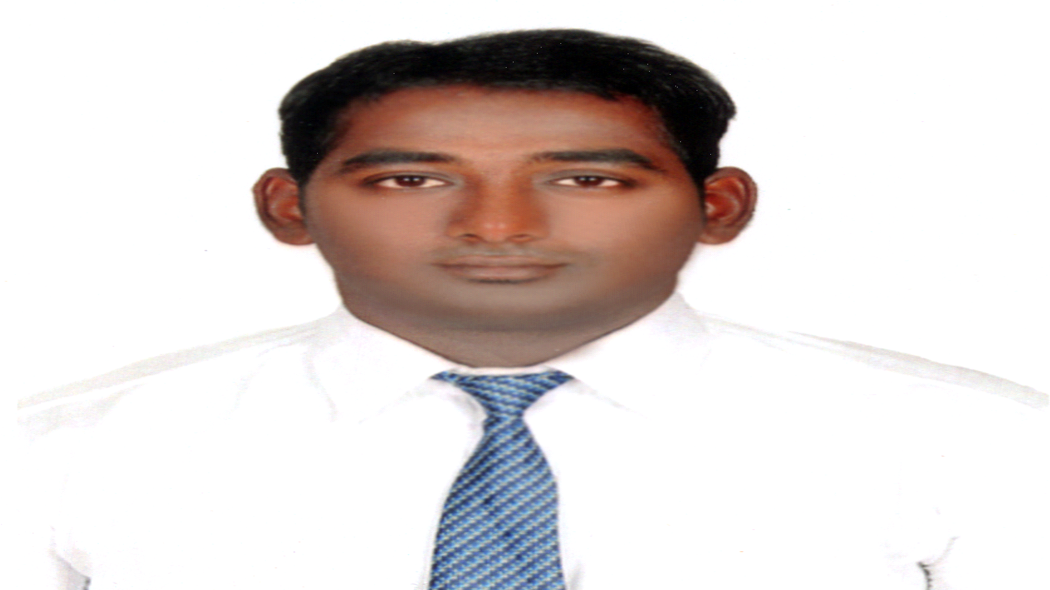

**E-Mail:imanfazi787@gmail.com**

**Mobile:0551729556**

**CAREER OBJECTIVE:**

To attain a challenging position in a supervisor organization that will be enable my knowledge and skills in the work allotted for me in effectively for the mutual development of the organization

**SUMMARY OF SKILLS:**

* Provide security staff with list of duties at the beginning of each shift.
* Tech new hires a security and trains them in learning the ropes.
* Establish priorities of security patrol and ensure that staff adheres to them.
* Provide visitors with helpful advice to ensure their security.
* Working on networking system and computer maintenance .
* Ability to perform multiple tasks effectively within deadlines.
* Excellent knowledge on security supervising an coordinating.
* A security supervisor oversees guard who protect private property against vandalism.
* Security officers also ensure the safety of people on their employer's premises.

**TECHNICAL SKILLS:**

* Operating System : Windows OS
* Win 98/2000/XP/Vista/Windows 7,8,8.1,10.
* MS Office Suite : XP/2003/2007(Word, Excel, Power Point, Outlook)
* Email/Accounts : MS Exchange , MS Outlook , Active Directory.
* Security : Experienced in Antivirus, Internet Security ,Spyware Removal tools, and CCTV Operations.
* Repairing Electric and Electronic materials, & components.
* Assembling and Dismantling all the electronic devices.
* To handling all type of Electronic things.

**COMPUTER SKILLS:**

* Basic Networking Configuration, System Administration.
* Tally, MS Office ,Visual Basics.
* Embedded system, Hardware and Software System Installation and Maintenance.
* Operating System : Windows 98/2000/2003/XP, Windows Vista,7,8,8.1,10.

**SUMMARY:**

* Ability to perform multiple tasks efficiently within deadlines.
* Initiator , motivator and good administrator.
* Excellent knowledge on security supervising and coordinating.
* A security supervisor oversees guard who protect private property against vandalism.
* Security officers also ensure that safety of people on their employers premises.
* Willing to learn new technologies.
* Comfortable with both live and remote troubleshooting situations.

**EDUCATION :**

* B.E. - ELECTRONICS AND COMUNICATION (2010-2014)
* 12th - HIGHER SECONDARY SCHOOL (2010)
* 10th - MATRICULATION SCHOOL (2007)

**EXPERIENCE:**

* Experience in ' AMPHERE ' E-bike and Solar bicycle company one year.
* ' SYS-TECH SOLUTION ' hardware and software solution six months.
* ' AERO travels ' air ticketing ,guiding and marketing.
* ' FOR U ' sales representative.

**PERSONAL DETAILS:**

Father name : Mrs. K.E. Jaheer Hussain

Date of Birth : 12.10.1991

Passport No : L4136425

Languages known : Tamil, English, Malayalam.

**DECLARATION:**

I hereby declare that the above given particulars are true to the best of my knowledge.

**Yours faithfully,**

                                                                                                    (MOHAMMED BAZIL.J**)**