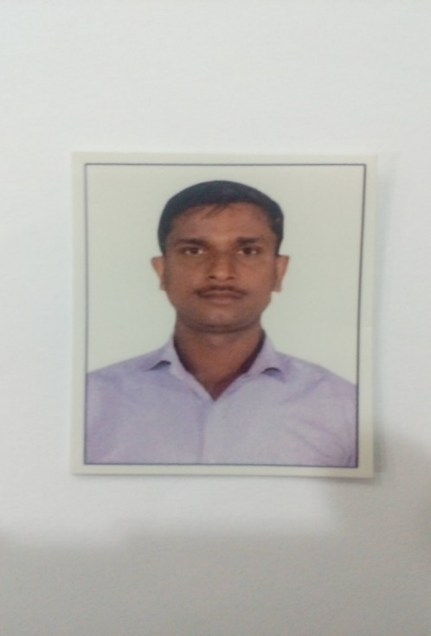Abhishek Kumar

Khobar, Saudi Arabia

Ph.no. +966 – 592733134/+91 – 9897167456

Email: - [abhishek.mba@outlook.com](mailto:abhishek.mba@outlook.com)

Career Objective

To obtain an accounting position where I will be able to Contribute my skill, knowledge and experience to a company that will give me an opportunity to develop and achieve the employer’s goal and my carrier as well.

Key skills summary of experiences handled

* Accounts payable process
* Treasury Process
* Payroll process
* Inventory Management
* Accounts receivable process
* Budgeting
* Management Reporting
* Expert in SAP FI/CO Module

Employment History

1. Accountant

Period of Experience – Feb 2013 to till date

(01St Feb.2013 to12th Feb 16 in India & From 14th Feb.2016 to Till Date Continue working in Saudi Arabia)



COMPASS ARABIA COMPANY LIMITED

(Industrial Catering & Facility Management Services)

Khobar, Saudi Arabia

Accounts Payable Process:

* Verify and posting of supplier invoices which was accounted by accounts assistance and store keepers from various locations/projects.
* Prepare suppliers reconciliation on regular monthly basis by obtaining statement from the suppliers
* Prepare supplier payments for due invoices by reconciling and verifying their due invoices for each supplier for approval of payment process.
* Follow and comply the company policies and procedures on all the aspects of transactions.
* Treat fairly and resolve the supplier queries on regards their invoices and payments.
* Create cost accruals for services/materials received from the supplier and yet to be received their invoices for accounting by analyzing the open purchase orders.
* Closely monitor and keep the supplier books clean by sort-out their disputed invoices.
* Manage and keep the clean records of supplier vouchers and payment documents with required supporting documents for audit compliances.

Accounts Receivable Process:

* Prepare invoices for sales or services rendered through the SAP system upon receipt of approved data.
* Timely follow up on payments to collect within the appropriate periods of due date to ensure all the invoices are being paid.
* Monitor customer account details for non-payments, delayed payments and irregularities.
* Research and resolve the payment discrepancies.
* Generate age analysis report to the management and forecasting the collection target.
* Maintain customer records such as contracts, invoices and others communication to ensure compliances for audit purposes.
* Follow and comply the company policies and procedure on all the aspects of transactions.
* Investigate and resolve customer queries.
* Maintain good relationship with the customers and ensure all the discrepancies and queries are solved at the earliest.
* Process accruals for which the sales and services rendered but to be invoiced to the customer and keep tracking until the invoices are processed and submitted.

Payroll Process:

* Process an average of 2000 employee’s salaries through SAP system.
* Verification and systemized salary process of employee’s time data which is received from each project with appropriate approval.
* Verification of payroll master data changes with management approved documents.
* Prepare payroll analysis report (Salary and Overtime) for management review and approval.
* Process bank transfer letters and salary cheques after management approval.
* Reconcile and review for system posting of processed payroll data.
* Generate employee’s pay slip in SAP and resolve their salary queries.

Treasury Process:

* Verify and posting of petty cash/expenses reimbursement voucher/documents.
* Process employee leave and final settlements payments by verifying and posting of documents.
* Prepare monthly bank reconciliations.
* Process company utility and telephone payments.
* Verify and posting of journal entries.
* Arrangement of cash and cheque deposits which is been collected from the customers.

Inventory Management

* Physical inventory verification conducted at all the projects on monthly basis.
* Spot verification on supplier delivery on quality and quantity as per specification on the PO
* Obtain monthly closing stock report with appropriate approval from each project.
* Verification and audit on store issues/receipts documents.
* Closely monitor on slow moving and near expiry food item stock.
* Maintain all the records on inventory adjustments and write off for audit compliance

General Ledger & Management Reporting

* Handle and perform on monthly closing of books up to date and prepare management reports on financial performance results.
* Prepare yearly budget on various projects based on available data and existing records.
* GL Cost Review
* Create accruals for employee benefit such as gratuity, Leave salary & air fare cost
* Prepare financial report for management review.
* Process intercompany transactions and reconciliation
* Prepare balance sheet schedule and review.
* Process & arrange for bank guarantees and tender bonds by coordinating through bank.

2. ACCOUNT EXECUTIVE

Period of Experiences from 2.8 Years (19th May 2010 to 07th Jan 2013)

KHALID BADR HAMOUD & ALMOJIL COMPANY

(CONSTRUCTION COMPANY)

Riyadh, Saudi Arabia

Accountabilities:

* Performed corporate general accounting duties to support 25 stores which included financial statement reporting and analysis, posting to accounting systems (A/R) & (A/P), reconciling bank statements, overseeing disbursements, maintaining G/L accounts.
* Assisted in budget process and prepared monthly, quarterly and annual depreciation expense schedules
* Prepared quarterly and annual Schedule B's, financial statements, payment schedules and financing schedules.
* Maintained fixed asset system, helped consolidate capital and fixed assets, and reviewed monthly, quarterly and annual fixed asset schedules for submission to planning and reporting.
* Performed general inventory accounting responsibilities including inventory cost analysis, pricing, inventory to mark-up, processing accounts payable invoices, and providing inventory control.
* Maintain other Accounts Related Work like: Supplier Reconciliation, Client Reconciliation, Taxation, Supplier Payments, Clients Outstanding, Petty Cash Work, and Monthly Debtors Creditors Aging and Prepare Cash Flow Chart.
* Coordinate the end of month closing process to ensure all corporate deadlines are met and information is presented in accordance with GAAP.
* Assist in Resolve Customer Related, Supplier Related & other Legal Related Discrepancies.
* Work with project teams and internal departments to develop and deliver training for the SAP FI/CO fixed assets accounting modules to Accounting, Network, Supply Chain, Information Technology and other Operations groups.
* Responsible for preparation of Monthly Working Board report and presentation to the senior management team.

3. ASSISTANT ACCOUNTANT

Period of experiences from 1.10 Years (10th July 2008 to 30th April 2010)

FEDDERS LLOYD CORP. LTD.

(STEEL STRUCTURE & FABRICATION)

Sikandrabad , Bulandshahr (INDIA)

JOB PROFILE:

* Finalization of monthly, quarterly and annual books of accounts.
* Liaison with Internal and Statutory Auditors.
* Consolidation of Group Accounts
* Preparation of Bank reconciliation statement. (Delhi, Sikandrabad & Haridwar).
* Reconciliation with HO, Inter-depot & Debtors.
* Verifying the bank Account and Accounts receivable.
* Submitting sales tax (VAT) e- return filing for (Delhi, Sikandrabad & Haridwar)
* VAT assessment preparation for Sikandrabad & Haridwar.
* Handling ESI & Labor office for employee’s benefit.
* Passing Debit note & Credit note.
* Preparation of Monthly Reports to HO.
* Preparation of Daily MIS to HO.

Education

* Certified Public Accountant (CPA) Pursuing

Enrolled in AICPA Exam

* Master of Business Administration (MBA) Finance & Marketing Passed in 2008

Punjab Technical University, Jalandhar (India)

* Bachelor of Commerce (B.com) Passed in 2006

Chaudhary Charan Singh University, Meerut (India)

Accounting Software Application

Category/Tool Software Proficiency

Accounting Software Peach tree, Tally & SAP FI/CO Proficient

Office tools M S Office Application Proficient

DTP Software Adobe photoshop & Corel Draw Proficient

Internal Training/Courses

* Supervisory Skills – July 2014
* Customer Service and Complaint management – Sep 2016
* SAP Training in FICO & MM – July 2014
* Firefighting & Fire Marshal – Dec – 2016
* HACCP Training
* HSE Training

Additional Certification

* SAP End User Certification in FI/CO module from ERP tech consultant, Delhi.
* One year part time P.G. Diploma in computer application from DIIT institute, Sikandrabad.
* Six Months Accountancy Training from Suneha Institute, Delhi.
* N.C.C ‘B’ Certified for Army Training.

Personal Details

Date of Birth 01st April 1985

Father’s Name Sh. Lavakesh Kumar

Marital Status Single

Language Known Hindi, English & Arabic (Only Speak)

Nationality Indian

Religious Hindu

Passport No. H 2582932

Indian Permanent Address B-31 H, Village: Sarkari Colony Gopalpur

Sikandrabad, District: Bulandshahr , U.P. (India)

Declaration

I hereby declare that all the above information is true and correct to the best of my knowledge.

**DATE Abhishek Kumar**