**CURRICULUM VITAE**

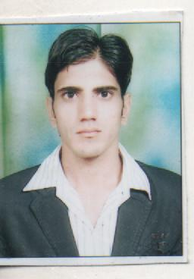

**AJAY KUMAR**

**H.NO. 429,**

**PATTI AFGAN,**

**GALI NO.6**

**KAITHAL.**

**Mob. No. +919416564720**

**E-MAIL ID ** [**ajayparjapti720@gmail.com**](mailto:ajayparjapti720@gmail.com)

**OBJECTIVE:**

To be associated with an esteemed organization to enhance my skills and to contribute to the growth of the organization.

**EDUCATIONAL QUALIFICATIONS:**

|  |  |  |  |  |
| --- | --- | --- | --- | --- |
| **Degree** | **Specializations** | **College/School** | **University/Board** | **Percentage** |
| **MBA** | **MARKETING/FINANCE** | **K.U.K** | **KUK** | **65%** |
| **B.COM.** | **COMMERCE** | **RKSD, COLLEGE, KAITHAL** | **KUK** | **63.3%** |
| **12th** | **COMMERCE** | **SS BAL SADAN SR. SEC. SCHOOL** | **HBSE** | **75.6%** |

**COMPUTER KNOWLEDGE:**

* Sound knowledge of C , C++, MS office.
* Sound knowledge ofInternet.
* Tally 7.2.

**EXTRA CURRICULUM ACTIVITIES:**

* Participated in Presentations.
* Participated in Seminars.

**Experience:**

* Ajay industries Pvt. Ltd. Haryana as senior sales & marketing executive**.**
* **since 26 dec.2017 in indiamart as senior sales and marketing executive.**

**Key Roles :**

* Taking appointments
* Meetings with wholesalers and manufacturers in order to sale product and services
* Taking orders from the dealers
* Achieving sales targets on monthly basis
* Maintaining existing sales and always focus on increase companys margin

**HOBBIES :**

* Diary Writing.
* Playing cricket
* Learning new things.

**STRENGTHS:**

* Positive Attitude.
* Hardworking.
* Self motivated.
* Leadership.

**LANGUAGES:**

* Hindi, English.

**PERSONAL DETAILS:**

Father's Name : Mr. Kaliram

Mother's Name : Mrs. Santosh rani

Date of Birth : 17/10/1992

Marital Status : Unmarried

Gender : Male

Nationality : Indian

**DECLARATION:**

I always give my best at my work. I believe in co-operation and teamwork. I firmly believe in sincerity and handwork. I declare that the above details are true to the best of my knowledge.

Date

Place - **( AJAY KUMAR )**