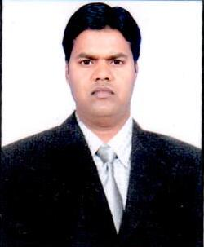**CURRICULUM VITAE**

**MOHAMMAD ASIF**

**WHATSAPP NO**: +**97155 5926698**

**Mobile India: +91 8860139778 ,+919871785801**

**Email** [**ID-Asif_khan_uae92@yahoo.com**](mailto:ID-Asif_khan_uae92@yahoo.com)

**Skype ID-Asifkhan907**

**Dubai, U.A.E Post Applied For : Automobile petrol Mechanic**

technician **Objective:**

Seeking a suitable position with substantial responsibilities where my varied experience would be fully utilized and where I could make a significant contribution to my employer which will gain me carrier opportunities.

**Personal Information:**

Father Name : Mohamed Abid

Date of Birth : 10/02/1985

Gender : Male

Nationality : Indian

Marital Status : Single

Religion : Muslim

Languages Known : English, Urdu & Hindi.

**PASSPORT DETAILS :**

Passport No : P 5159433

Date of Issue : 5/01/2017

Date of Expiry : 4/01/2027

Place of issue : Bareilly.

**Summary of Qualification:**

* Metric pass

## Work Experience: Malty brand model Audi, vw , bmw ,skoda,hyundai,land rover

**Honda,lexus,toyota ,ford,gmc,seat all vehicle experience.**

## Currently working in Liberty Service centre LLC. and Budget Rent Car Group, Dubai as a mechanic from 11, SEPTEMBER 2013 to till date.08 SEPTEMBER, 2016

* Worked in **Al Habtoor Motors Group (Dealer) ,Dubai** as a **Mechanic** from **June 2010 to June 2013.**
* Worked in **Sai Automobiles PVT. LTD.( Skoda Dealer )** , India as a technician from **may 2009 to June 2010 .**
* Worked in **excel motors PVT. LTD.(Dealer)**, India as a technician from **February 2006 to December 2008**.

**Declaration:**

I hereby declare that the above mentioned all information is true and correct to the best of my knowledge and belief. I assure you that if I am given an opportunity to work with you. I will do my duty to the best of my ability. **Mohammed Asif**