**DHANESH.K.V – MECHANICAL ENGINEER**

✆ : +919744319982 (INDIA)

🖂: dhanesh16@gmail.com

📪: INDIA

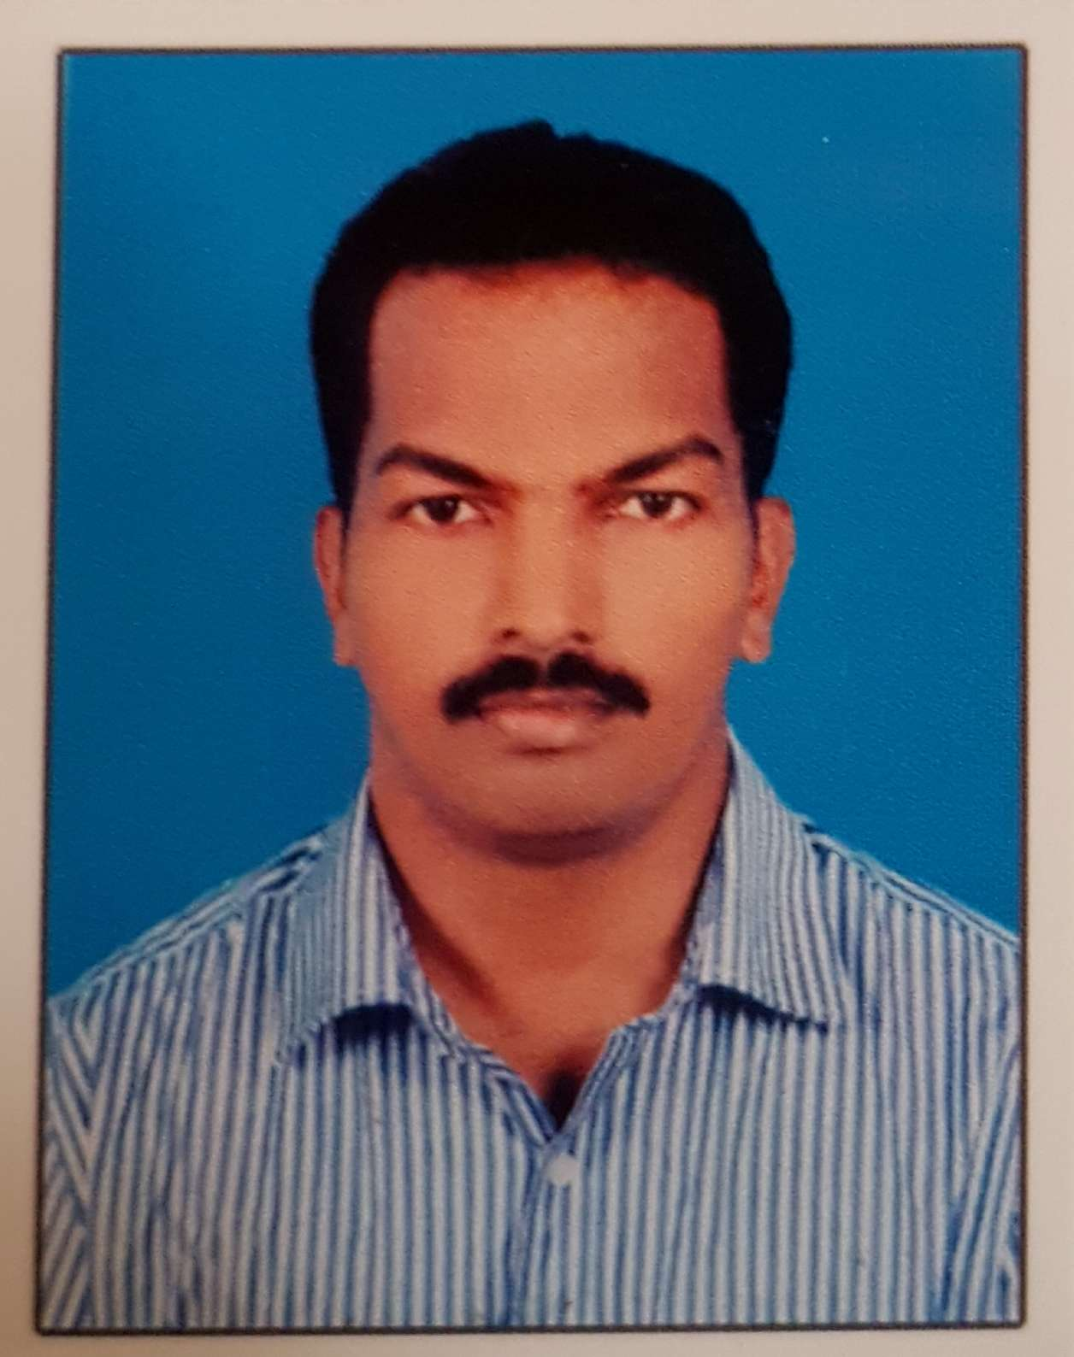

Seeking assignments in **Project Engineering / Quality Assurance & Control** inMEP / Oil & Gas/ Petrochemical/Marine Industry/ preferably in UAE/ Qatar/Oman/Bahrain

**SUMMARY**

* **10+ years** of experience in Quality Management and Project Engineering, Systems entailing HVAC, Fire Protection, Plumbing, , static and rotating equipment, Piping, Material Inspection, fabrication, welding Operations, NDT, majorly for, MEP, Oil & Gas, Industrial and **Airport** Projects
* Holds the merit of executing the Projects like **Airport project (Development of Muscat International Airport)** and EPC Projects like Sulphuric Acid Plant, Blast furnace, coke oven, Shutdown work of Sulphuric Acid Plant.
* **Airport Project –** Installationof HVAC systems, chilled water piping, major equipment, fire protection systems and Plumbing systems for PTB, PIERS and Forecourt buildings and follow up for MEP service coordination and Final ceiling/Area clearances, Plant room inspections and Inspection of fire and life safety systems.
* Experience in Piping Operations, Equipment Inspections including Pressure Vessels, Storage Tanks, Rotary Equipment’s, HVAC Equipment’s & related ducting, piping, valves & accessories, Plumbing, fire protection system & support Structures.
* Adept in conducting inspection, taking stringent quality measures & capably organizing quality awareness programs in the organization
* Internal audits, quality training programs, attended safety trainings and knowledge of ACONEX (online project document control)
* Good analytical, troubleshooting and inter-personal skills with proven ability in driving numerous quality enhancement, process improvement and cost savings initiatives during the career span.
* Certifications : **NDT LEVEL II, CSWIP 3.1 & ISO LEAD AUDITOR**
* Codes and Standards – **ASME, ASNT, AWS, API, BS, NFPA and DW144**

**AREAS OF EXPERTISE**

* + Equipment Drawings, Process & Instrument Diagram (P&ID), Isometric / GA & Structural Drawings
  + Preparation of QAP, ITP, MST and Work Procedures, WPS, PQR and WQT
  + Ensuring that QA/QC procedures are correctly followed at site and review of inspection records for compliance with quality test plans
  + Auditing of Sub-contractor’s Project quality plan, QA/QC Procedures, site activities, and follow-up on Remedial actions.
  + Preparation and submission of Material Approval Submittal and incoming material inspections
  + Installation of MEP services as per approved drawing, service coordination and follow up for final ceiling clearance
  + Installation of HVAC ducts and accessories(VCD, VAV and fire dampers, Diffusers, Grills and Customized air outlets)
  + Installation of Piping for Chilled Water circuits, Fire protection system and Plumbing services(CS,CI, HDPE, UPVC & PP)
  + Equipment installations – **Water and air cooled chillers, Air Handling units, Fan coil units, DX units and Refrigerant piping, Extract fans, Pumps, Heat exchangers, Pressurisation units, filtration units, chemical dozing system and vacuum degassers.**
  + Fire stopping inspection as per ROP approved fire rated drawings and engineering judgements
  + Issuing of Non-compliance reports
  + Can manage technicians and labours and work distribution and material management
  + Maintaining inspection logs, registers and managing weekly schedule for planned inspections
  + Preparation of Material Identification Reports, Installation checklists, Stage Wise Inspection Reports, Final Inspection Reports, RT Reports & Testing Reports
  + Inspection of Fabrication for tanks, pressure vessels, piping spools, support structures and welding
  + Visual Inspection of Weld, follow up for Weld Repairs, RT Film Interpretation
  + Installation of acid and gas piping (CS, CI, GI, SS, Alloy steel, FRP pipes)
  + Inspection of Rotary Equipment’s and valve packages
  + NDT, Hydro Tests, Pneumatic Test, Sand Blasting/ Painting and Polyurethane Coating on LPG Mounted Bullets

**ORGANIZATIONAL EXPERIENCE**

**Jun’2012 – Dec 2017: Bahwan Engineering Company LLC, Oman as Project Engineer - Mechanical**

**Project Executed: Development of Muscat International Airport; Contractor: Joint Venture of BECHTEL, ENKA & BAHWAN Engineering Company; Consultant: HILL International and TENABLE (Fire and Life safety)**

**Key Result Areas:**

* + Preparation of Inspection Test Plans, Method statements & Procedures
  + Familiar with Equipment Drawings, Process & Instrument Diagram (P&ID), Isometric Drawing, GA Drawings & structural drawings
  + Ensuring that QA/QC procedures are correctly followed at site
  + Auditing of Sub-Contractor’s Project Quality Plan, QA/QC Procedures, Site Activities and follow-up on Remedial Actions.
  + Review of Material Approval Submittal and incoming material inspections
  + Installation inspection MEP services as per approved drawing, service coordination and follow up for final ceiling clearance
  + Installation of HVAC ducts and accessories(Volume control and fire dampers, Diffusers, Grills
  + Installation of Piping for Chilled Water, Fire protection system and Plumbing services(CS,CI, HDPE, UPVC & PP)
  + Equipment installations – Water and air cooled chillers, Air Handling units, Fan coil units, DX units and Refrigerant piping, Extract fans, Pumps, Heat exchangers
  + Issuing of Non-compliance reports.
  + Coordination for inspection with consultants / Third party inspection agencies
  + Carbon steel piping fabrication – stage wise inspection.
  + Formulating WPS & PQR, welding inspection, conducting welder Test as per approved procedures, NDT and Related Documentation
  + Inspection of sandblasting and Painting.
  + Maintaining inspection logs, registers and weekly schedule for planned inspections
  + Preparation of line history sheet for weld joints, track sheets for room clearance and ceiling clearance.
  + Organizing radiography test and reviewing of RT films, Hydro test and Pneumatic test inspection
  + Preparation of test packs, maintaining records/Checklists.

**Sep’09-May’12: Furnace Fabrica (India) Limited,** Mumbai **as Project Engineer – QA/QC**

**Project Executed: - Sulphuric Acid Plant (210KT Capacity) Project at Hindustan Zinc Ltd.-Vedanta, Dariba – Rajasthan,**

**Consisting of Roaster, Towers, Convertor, Heat Exchangers, Storage Tanks, Pumps and Motors, Piping, Ducts**

**& Structures); Consultant & Inspection – Aker Solutions**.

* Shutdown Project (Sulphuric Acid Plant) at Sterlite Industries Ltd. – Vedanta Group, consisting of Heat Exchanger and Ducts);

Third Party Inspection – SGS India Pvt. Ltd.

* Coke-Oven Project at Sesa Goa-Vedanta Group, consisting of Hopper, Ducts and Structures
* Mercury Removal System at Hindustan Zinc Ltd., Chittorgarh – Rajasthan, consisting of Structure’s, Mercury Tower, Piping and Storage Tanks
  + Sulphuric Acid Plant – Roaster 5 (210KT Capacity) Project at Hindustan Zinc Ltd.-Vedanta, Dariba - Rajasthan, consisting of Roaster, Towers, Convertor, Heat Exchangers, Storage Tanks, Silos, Pumps & Motors, Piping, Ducts and Structures);

Consultant**:** MECON Ltd.

**Key Result Areas**

* Led QA/QC and NDT Activities (RT, UT & PT) and deftly coordinated with clients and third party for inspection.
* Preparation of job procedures and Inspection test plan as per codes.
* Familiar with Equipment Drawings, Process & Instrument Diagram (P&ID), Isometric Drawings, GA Drawings, Structural Drawings
* Incoming material inspections and reviewing traceability of materials with respect to mill certificates
* Carried out stage wise inspections during fabrication of equipment, tanks, piping and structures as per approved drawings and ITP
* Deftly interpreted welds by reviewing RT Films
* Assessed WPS, PQR, and WPQ and issued Welder Cards on project
* Formulated welding procedures and performed PQR & WPQ for the final approval
* Conducted Welder Test as per approved procedures
* Preparation of test packs and witness Hydro test &Pneumatic test
* Sandblasting and Painting Inspection and preparation of reports
* Drafted Inspection Reports, Worksheets and maintained Inspection Records.
* Contributed in carrying out Pre-Commissioning & Commissioning Activities.

**May’08-May’09: Macmet India Ltd., Kolkata as Site Engineer**

**Project Executed: Poly Urethane Coating on LPG Mounted Bullets for Indian Oil Corporation Ltd. (Gujarat Refinery); Consultant – TOYO Engineering Ltd.; Third Party Inspection – TUV**

**Key Result Areas:**

* Executed Blasting and Painting Activities as per project requirement, quality standards and HSE requirements.
* Handled 2 supervisors and 5 technicians
* Daily work planning, material management and maintenance of machines and tools.
* Inspected Blasting Profile and DFT of paint.
* Deftly reviewed Test Packs (Pull Out Test) & conducted Holiday Test (Spark Test)
* Preparation of Inspection Reports, Worksheets, and maintained inspection records.
* Coordinated for third party and client inspections.

**Jan’07-Apr’08: Airoxnigen Equipment Pvt. Ltd., Ahmedabad, Gujarat as Project Engineer (Fabrication & QA/QC)**

**Project Executed: - Skid Mounted Air Dryer Unit for Reliance Industries Ltd. consisting of Air Receivers, Filters, Silencers &**

**Piping); Consultant: AKER Kvaerner; Third Party Inspection: BVIS**

**- PSA Nitrogen Plant for Nirma Ltd. consisting****of Adsorption Vessels, Air Receivers, Filters & Silencer);**

**Consultant & Inspection: Udhe India Ltd.**

**Key Result Areas:**

* Headed QA/QC and NDT Activities as per the contract/project requirements
* Ensured proper coordination with Third Party for inspection
* Made arrangements for inspection at various stages of fabrication for equipment’s, piping and structures.
* Conducted fit-up & visual inspection of weld & monitored welding parameters as per WPS
* Assessed the receiving material like pipes, plates, fittings, structural materials, etc.
* Welding inspections, RT, PT and UT
* Accurately interpreted welds by reviewing RT Films
* Reviewed Test Packs & performed Hydro & Pneumatic Test
* Effectuated Painting Inspection and designed Inspection Reports
* Drafted Inspection Reports, Worksheets and maintained Inspection Records.

**EDUCATION**

**B.Tech. (Mechanical) from Bharathiyar College of Engineering and Technology, Karaikal, Pondicherry University**

**Certifications**

* **CSWIP 3.1**
* **ISO 9001-2008 LEAD AUDITOR CERTIFIED**
* **NDT - ASNT LEVEL-II** in Radiographic Testing, Ultrasonic Testing, Dye Penetrant Testing and Magnetic Particle Testing

**IT Skills:** Well versed with MS-Office, AutoCAD & Internet Applications

**PERSONAL DETAILS**

Date of Birth: 16th July, 1984

Nationality: Indian

Passport No.: M1043069

Linguistic Abilities: English, Hindi, Tamil, Malayalam and Guajarati.

Permanent Address: Koodathil Meethal House, Chalakkara, New Mahe (PO), Kerala, India

Marital Status: Married

Visa Details: Employment visa

Driving License no. PY03 20130000762 (INDIAN)