**1-TO**

- .. F=

STAR

I_ **L** :'» J

I

8 U l l f *0 11* T R U S T

**ETA STAR ENGINEERING** & **CONTRACTING W.L.L**

**DOH.A, QATAR**

**Fo Group Leader** - **Addition and:De letioe F0,em,**

**Date:** *0 1-* i I - 2 *o* I

Name EmpNo.

Trade

(

Site

II

(

SHAJ)Fr.B AHMED

\ *0 0* i 3 *0"15* ,G

t>U c_-,1N bl E_v

-

WO g_ \CE *\2.* s ,-\ o..SfT TRL

Effect From

Workers Handled

ovi·- \ -I '2- o1 S

*2 .*

Engineer /Supervisor

Reason for (Addition/Deletion)

M_ C, .:.z o--Yn'(V) *e* \ *\+o °)\.J L-.*

1--1 *e* h o-:S, *(l°-o* d Fi<f n>-*en* c.9- wi +-h l "L-1

b *\)* c.A \)

The above candidate has been considered /deleted as Group Leader. Please make a change/ note in your records.

Regards,

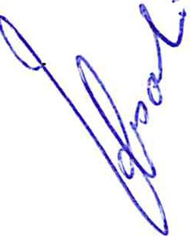7 tN.:: J1.+=>. 9,*111 .12-CJ, v*

# II

**Super**· **v***)***isor**

Engmeer

Project Manager

Review by HR

Page **1** of **1**