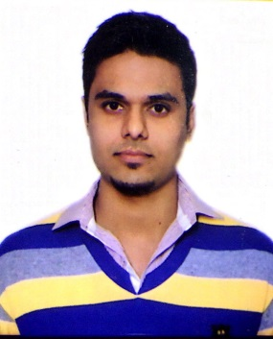CURRICULUM VITAE

Apply For Merchandiser

Farhan Ahmad

Address :- B 46/4 Lane No 7

Shaheen Bagh, Delhi 110025 India

Contact No. : +91-7042816419 / 9582780631

Email Add : farhan77ahmad77@yahoo.in

# OBJECTIVE:

To Acquire Sufficient and Honourable Means Of Earning Through Hard Work & Determination

# PERSONAL DETAILS:

Father’s Name Zubair Akhtar

Date Of Birth **01-11-1993**

Marital Status Unmarried

Nationality Indian

Religion Islam

Driving License N/A

Passport No. **M – 1206931**

Place Of Issue **Patna**

Date Of Issue **20/08/2014**

Date Of Expiry **19/08/2024**

**ACADEMIC QUALIFICATIONS:**

* BCA From RTU in 2016 with 71.87% Marks.
* Intermediate From B.S.E.B in 2012 with 60.02% Marks.
* Matriculation From CBSE in 2009 with 67% Marks.

## LANGUAGE (SPEAK & WRITE)

* English, Hindi, Urdu, Arabic(Working Knowledge)

## EXPERIENCE:- 3 Years

* Working As Stocker In Big Bazaar (Future Group) From 01/02/2015 to Till Date

## REFERENCE:

* Will Be Furnished On Demand

Date: 29/07/2017 Signature

Farhan Ahmad