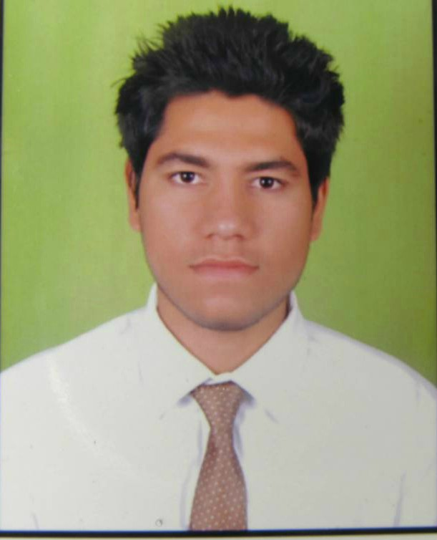**RAGHUDEV SINGH**

**Mobile:** +91-7827087077 **E-mail:** singh.raghudev@yahoo.com

+91-9899895080 raghumeds@gmail.com



**In quest of entry level assignments with an organization**

**Academic Credentials**

|  |  |  |  |  |  |
| --- | --- | --- | --- | --- | --- |
| **YEAR** | **DEGREE** | **INSTITUTE** | **UNIVERSITY/BOARD** | **SPECIALIZATION** | **GRADE** |
| 2006-2007 | Class X | Kendriya Vidyalaya sector-3,rohini,delhi | CBSE | N.A | 73% |
| 2008-2009 | Class XII | Kendriya Vidyalaya sector-3,rohini,delhi | CBSE | Science | 63.4% |
| 2009-2013 | BACHELOR OF TECHNOLOGY | Hindu College Of Engineering,Sonepat | Maharshi Dayanand University , Rohtak | Mechanical | 61.30% |
| 2014-2015 | Post Graduation Diploma | Marine Engineering And Research Institute, Mumbai | Indian Maritime University, Chennai | Marine Engineering | 69% |

**Technical Skills**

* **Designing Software** : AutoCAD , CATIA , PRO-E.
* **Database** : GD&T , MS Office.
* **Language Known** : Basics of C++.
* **OS** : DOS, Windows.

|  |
| --- |
| **Job Experience** |

* Worked as a 5th Engineer in the vessel Altus Exertus operated by Marine Engineering And Diving Services, Sharjah, UAE from 15/4/2015 to 16/7/2015.

**Academic Project and Internship**

**Project** : Balloon Rocket Car Science Project.

**Internship**:

* Honda Motorcycle & Scooter India Pvt. Ltd , Sector 3, IMT Manesar, Gurgaon, Haryana.

Department- Steel Machining Duration: 20 JUNE’11 – 22 JULY’11

* Machino Plastic Ltd (Maruti J.V Complex), Gurgaon, Haryana.

Department- Production Duration: 18 JUNE’12 – 18 AUG’12

* Honda Motorcycle & Scooter India Pvt. Ltd , Sector 3, IMT Manesar, Gurgaon, Haryana.

Department- Paint Duration: 15 JAN’13 – 15 MAY’13

**Accolades**

* Awarded as
  + Silver medal in Inter school TAEKWONDO championship 2004.
  + Mr. Fresher HCE 2009-2010.

**Extramural Engagement**

* Attended workshop on “Automobile Mechanics And I.C Engine Design (Autospark)”.
* Won silver medal in Inter school TAEKWONDO championship 2004.
* Appeared for PAINTING competition organized by NIIT , Rohini.
* Participated in various cultural activities as guitarist.
* Volunteer under Institute of mechanical engineer (IMechE).
* Certified Skilled in mechanical designing softwares from “CADD CENTRE”.
* Attended workshop on “X-pentabot Robotics (Thinnkware)”.
* Certified trained in safety courses of seafarer approved by MACD,USA.

**Personal Dossier**

Nationality : Indian

Passport Number : K0135419

Father’s Name : Mr. Rambir singh

Mother’s Name : Mrs. Mithilesh

Date of Birth : 1st Apr,1992

Marital Status : Single

INDos no. : 14EL1144

CDC No. : MUM 245025

Permanent Address : D-15/250, Sector-3, Rohini, Delhi-110085

Linguistic Skills : English & Hindi

Strength : Determined, Hardworking, Responsible, Quick Decision Making, Risk Taking

Ability, and team Building Skills.

Hobbies : Music, Reading, Exercising, travelling and hiking with friends.

**Declaration**

I hereby solemnly confirm that all the information furnished above is true to the best of my knowledge.

Date:

Place: New Delhi **RAGHUDEV SINGH**