**Curriculum Vitae** 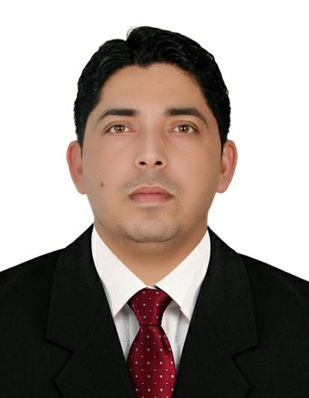

**Career Objectives**

To identify a challenging position and to be an integral part of growth oriented organization where in I wish to consolidated upon my experience which I have acquire throughout my noteworthy career and contribute towards the organization profitability.

**PRECISE**

**Summary - work Qualities:**

* **Total 8 years of Experience** in the Field of Cleaning supervisor
* Punctuality
* Friendly, cooperative and willing approach to assisting others as needed, and in undertaking routine work as well as special assignments.
* A good team player able to relate to people with diverse cultural background in a variety of contexts.
* Hard working, focused and responsible with good organization ability.
* Confident dynamic, fast learner able to **adapt to any environment** within very short duration.
* Positive and proactive working attitude and high ethical and integrity standards.

**Personal Details**

**Name :** Pradeep Kumar

**Date of Birth** : 18/02/1983

**Gender :** Male

**Nationality :** India

**Language :** English, Hindi, Arabic, Punjabi,Nepali

**Marital status :** Married

**Call :** +918626932748

**Email : pardeep_sharma198210@yahoo.com**

Driving License : LMV Manual UAE

**Education**

1. Senior Higher secondary pass from HP Education board.

(2) Bachelor of Arts from HP University.

**Skills**

* Proficiency with MS Office Products
* **Programming skill in Advance Excel**
* Word
* PowerPoint
* Office Outlook

**Work Experience**

**In India**

1. Worked as a Camp Boss with JMC Engineering & Constructor Ltd (India) from 2007 to 2009.

**Employment Overview (Experience Abroad 7 years )**

· Worked as a Cleaning Supervisor cum Camp Boss with **DSC Construction Ltd (Libya)** from 2009 to 2011.

· Worked as a **Cleaning supervisor with ETA Facilites** Management from 20/04/2012 to 19/8/2015

· 28/ 04/ 2012 To 08/ Jan/ 2014 worked as a cleaning supervisor at Jumeirah Lake Towers Dubai.

· 11/ Jan/ 2014 To 02/ jul/ 2015 worked as a cleaning supervisor at MOH Ibrahim Bin Hamad Obaidullah Hospital Ras al khaimah.

. Worked as a Senior Supervisor with Tanzifco Emirates L L C from 25/10/2015

to 12/12 / 2017 MOH Fujairah hospital UAE.

PRADEEP KUMAR