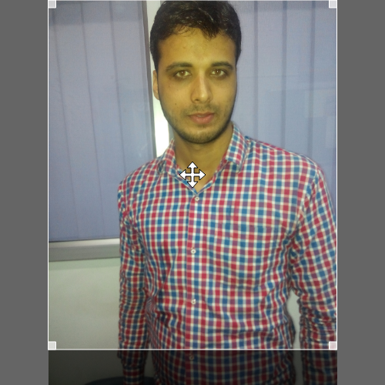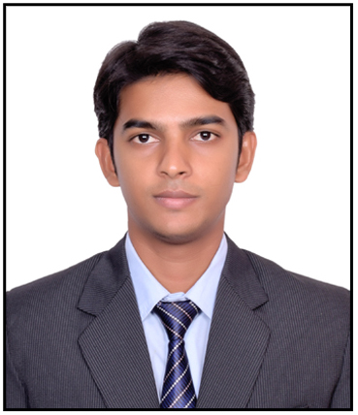

**ADITYA NATH TRIPATHI**

**Adress**- **Dubai,UAE**

**E-Mail**: [adityatripathi9519@gmail.com](mailto:adityatripathi9519@gmail.com)

**Contact**: **+91 9088462004**

**Specialization: ACCOUNTS & AUDIT**

**Objective**

Intend to build a career with leading corporate of dynamic business environment with committed & dedicated people, which will help me to explore myself fully and realize my potential.Willing to work as a key player in challenging & creative environment to achieve the corporate goals.

**Professional Expereince:**

**Total 3 years 4 month experience**

**1-Primas Career Management Consultants LLP (Kolkata,India)**

Working as Accountant cum Admin From 1st June’2017 to Present.

* Daily bookkeeping and accounting processes
* Monitor billing for compliance with all internal policies
* Prepare Jounral entries for prepaid expences and deffered revenue
* Handling petty cash
* Bank reconciliation statements (Banking)
* GST compliance
* Account finalization
* Prepration of daily reports on Bank deposit summary
* Dealing with customer
* Receiving Amount from client
* Management information system MIS
* Financial reporting and other administrative requirnments for management
* Coordinating with auditor in prepration of year end audit
* Managing documents & Flies
* Attandance & Salary sheet preparation
* multifaceted general office support

2-**Krishna Telecom (Kolkata ,India)**

**Worked as Accountant from 28 March’2016 to 4th July’2016**.

Raising bills

* + - Create vat report for Vat challan & returns
    - Day to day entry
    - Cash Handling
    - Maintaing cash book
    - Accounts reconciliation
    - Management Information system

3**- Rajsquare Manpower Pvt Ltd. (Kolkata,India))**

Worked as Data entry operator cum Accounts executive from 1st May’2014 to 31st Oct’2015.

* + - Raise invoice with service tax
    - Day to day expence entry
    - handling petty cash
    - service tax challan prepration & return filing
    - Account finalization

**Technical Skills & Professional trainning**

**C.I.A(**Certified Industrial Accountants)from ”The Institute Of Computer Accountant”.

* MS-Office ( M.s word , M.s Excel , Powerpoint )
* Business Accounting.
* Tally.
* ACE
* Accounts Reconciliation & Finalisation.
* Income Tax & TDS
* VAT & Service Tax.
* Goods & Service Tax

**Educational Qualification**

|  |  |  |  |
| --- | --- | --- | --- |
| **Examination** | **Year** | **Board/University** | **Marks** |
| B.com | 2018 | IGNOU | 59% |
| Higher Secondery | 2012 | UP BOARD | 66% |
| 10TH | 2010 | UP BOARD | 60% |

**Field of interest**

* + Playing cricket
  + Internet Surfing

Listning Classical song

**Personal Information**

Passport No-N7759200

Marrital status-Single

**Language Known:**

**English ,Hindi,Bengali**

**Declaration :**I hereby declare that the information furnished above is true to the best of my knowledge.

**Place** :Kolkata,India

**Date-24/12/2018 Aditya Nath Tripathi**