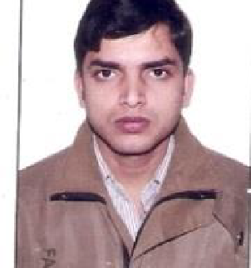

# RAVI KUMAR SHARMA

H. NO-2035,pillanji, Kotla,Mubarakpur. New Delhi-110003

09717216628, 9213480254(CELL-DELHI)

Email id: [ravisharma12oct@yahoo.com](mailto:ravisharma12oct@yahoo.com) Passport Details:-

* Passport no. : H2063570
* Date of Issue : 08/12/2008
* Date of expiry:07/12/2018

# Career Objective

To have a dynamic career where my potential can be utilized,and seeking to assume demanding leadership assignments.

# Summary of capabilities

* Good command in the technical area of my field
* Self motivating
* Good team spirit
* Optimist
* Good knowledge in computer hard wear networking and Ms office

# Professional Experience

1. Organization : Petron Engg. Cons. Duration : 04-06-2003 to 29-10-2007 Designation : Electrical technician

# Job Responsibility

* Maintenance(DG)
* Repairing(DG, light, wiring)

1. Organization: Powerica Ltd.

Duration : 12-01-2008 to 05-04-2010

Designation: Electrical technician

# Job Responsibility

* Maintenance
* Repairing

1. Organization: Emrest Trading Associates (uae) Duration : 09-11-10 to 17-05-11 Designation: Electrical maintenance technician

# Job Responsibility

* Maintenance
* Repairing

1. Organization: CHS (Client- Tanishq, Titan Industries Ltd.) Duration : 25-05-11 to till date

Designation: Electrical maintenance Incharge

# Job Responsibility

* Maintenance(DG)
* Repairing(light, DG, wiring)
* Faire fighting, and ac ,Amf panel,
* Hard wear networking
* Fire fighter and Safety officer
* Online ups

# ACADEMIC CREDENTIALS

* Passed - 10+2 + Diploma in electrical engineering

Personal Details

Date of Birth : 12-10-1985

Father’s Name : Late. Umashankar Sharma

Religion : Hindu

Languages : English, Hindi

Marital status : Married

Permanent Address: Village – Mairwa tola sakara, post- Mairwa,

Distt. – Siwan (Bihar)

Date – 17-09-15

Place – Delhi. Signature