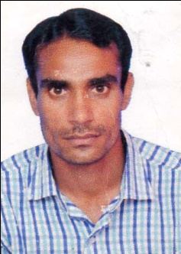**NAME : Mritunjay Pandey**

**CONT. NO : + 918052194351**

**Email ID : pmritunjay79@gmail.com**

**OBJECTIVE:** Looking for an organization which can justify my skill with a proper growth (Financial and Skill level).

**EDUCATIONAL QUALIFICATION :**

|  |  |  |  |  |
| --- | --- | --- | --- | --- |
| **COURSE NAME** | **COLLEGE/UNIVERSITY** | **STREAM** | **YEAR** | **% PERCENTAGE** |
| Matriculation(10th) | B R H S S RAMPUR POKHARAPAR DEORIA | SCIENCE | 2002 | 51 |
| Intermediate(12th) | A. D. I. C. Gambhirpur Malibari Deoria  U.P. Board | SCIENCE | 2004 | 61 |

**EXPERIENCE:**gulf country HVAC DUCTMAN

experience three years and India 5years.

**STRENGTH:**

* Quick Learner
* Flexibility
* Hard-working

**PERSONAL DETAILS:**

Name : Mritunjay Pandey

Date of birth : 07-11-1984

Address : Vill- Surjahi, Post- Barahara, Dist- Deoria (U.P.)

Sex : Male

Language Known : Hindi and English

Hobby : Listing To Music

Marital Status : Married

Religion : Hindu

Citizenship : Indian

**Passport Details –**

Passport No. : N3350077

Date of Issue : 14/09/2015

Date of expiry : 13/09/2025

Old passport No. : G5699022