**RESUME** 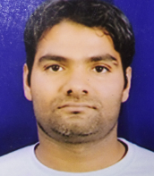

NAME : TABARAK ANSARI

POSITION : PLUMBER

DATE OF BIRTH : 23 JAN 1984

STATUS : MARRIED

CITIZEN : INDIAN

CONTACT NUMBER : 00919968636637

EMAIL ADDRESS : [tabarak198400@gmail.com](mailto:tabarak198400@gmail.com)

LENGUEAGES KNOWS : ENGLISH HINDI ARABIC AND URDU

PASSPORT DETAILS : N5984130

VALID UNTILL : 2026

PLACE OF ISSUE : DELHI

OLD PASSPORT : F5278631

DATE OF EXPIRY : 2015

RELIGION : MUSLIM

EDUCATIONAL QULIFICATION : 10TH 12TH PASSED

**PROFESSIONAL EXPERIENCES IN SAUDIA ARABIA**

POSITION PLUMBER GULF CO-OPERATION SYMBOLS CO.LTD

MANIFA CAUSEWAY ,RASAL KHAIIR CAUSEWAY ,

HAWAIYAH CASUSEWAY 2006 TO 2015

TABARAK ANSARI

DATE 19/09/2016