**MUNEEB AHMAD** 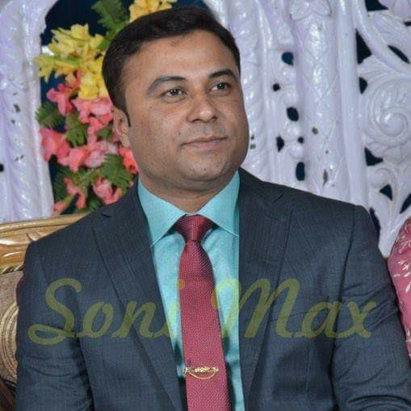

**P.O. Box 6058, Riyadh 11442, K.S.A.**

**Ph. +966-533766011,**

**Email:** [**muneebahmad.3254@gmail.com**](mailto:muneebahmad.3254@gmail.com)

**PROJECT SECRETARY/DOCUMENT CONTROLLER**

*Creating positive strategic partnerships with top Executives to achieve corporate success*

Over 7 years of experience for successfully providing a complete Administrative and Secretarial support to Assistant General Manager & high level Executives. Proven ability to organize and accomplish a number of Simultaneous Projects within time constraints. Excellent Organizational Skills, Accuracy and Attention to Detail. Highly skilled in Drafting Documents and Communications. Powerful Verbal & Written Communicator with the wisdom to foster open Relationships while maintaining Confidentiality. Extensive experience in Planning and Coordinating the entire Department's Administrative functions.

* Creates Project Status and Monitoring system to track and Monitor progress & Timelines for more than 30 Multimillion Saudi Riyal real estate Development Projects streamlining the flow of information.
* Reduces document generation and turnaround time by 75% by designing templates that automated high document production.
* Distinguishes by others by a tenacity to become an expert in the Executive Support Role and creating a Synergetic Relationship with Executives to increase achievements that impact Organizational growth.

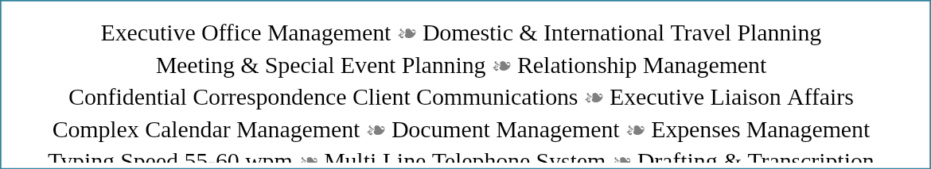

**PROFESSIONAL HISTORY**

**AL-RASHID ABETONG CO. (RIYADH, K.S.A.) Apr 2011 up to Present**

**Secretary – Project Administration / Coordination**

*High profile executive level Administrative Position supporting Deputy General Manager, Project Coordination Manager along with Senior Project Coordinators for highly valuable ongoing Projects. Manage time allocation for Deputy General Manager & Project Coordination Team by meticulously Coordination Meetings, Appointments and Events. Utilize expertise and sound judgment in handling competing priorities. Ensured seamless travel experience for Executives by arranging complex International and Domestic travel arrangements and itineraries with commercial travel vendors. Review, prioritize and takes action upon all incoming communication for Executives including emails, telephone calls and internal correspondences.*

**Job Role**

* Maintain records of all ongoing Projects and assist entire Project Team in their movements.
* Take Minutes of Meetings to maintain records for the Operations & Project Team.
* Develop and maintain Document Control Processes for the efficient management.
* Maintain a proper and user friendly filing and document control system for recording and tracking of all documents for the project team and department.
* Support the officers and project team in daily admin roles and assist to keep stock of stationary supplies for the department.
* Perform data-entry, recording, printing and filing duties.
* Undertake any ad-hoc admin projects/duties as required.
* Coordinate travel arrangements inclusive of air-ticket, hotel accommodation, visa arrangements, claims etc.
* Assist to check and verify staff claims and invoices for project team.
* Prepare and raise purchases requisition for purchase of office equipment’s for new staff
* Cooperated as Secretary in **Sales Estimation & HR Administration** during Company requirement.

**GRACE TOURISM & MARKETING Pvt. Ltd.** **(NEW DELHI, INDIA) Nov. 2008 - Dec. 2010**

**Administrative Secretary**

**Job Role**

* Handled all Operations serve under the Project Manager.
* Handled all Paper Works under Administration.
* Worked to present the Plans and Products to Clients while attending the Conferences.
* Worked to understand problems & inconvenience in service & then giving the best resolution through software engineer.
* Worked to manage all plans regarding the Clients Travel.

**MPHASIS INDIA PVT. LTD. (INDIA) Jan. 2006 - Oct. 2008**

**Team leader**

**Job Role**

* Handled a team of 42 employees who were working for AIRTEL BHARTI process as inbound platform.
* Understand problems & inconvenience in service & then giving the best resolution.
* Worked to given resolutions along with maintain the call timing with good quality score through employees.

**QUALIFICATIONS**

**Academically Bachelor of Commerce**

Shobhit University [Meerut - India]

**Special Skills**

* Demonstrated capacity to provide comprehensive support for executive level staff; excel at scheduling meetings, coordinating travel and managing all essential tasks.
* Proven track record of accurately completing research, reporting, information management and marketing support activities within demanding time frames.
* Adept at developing and maintaining administrative processes that reduce redundancy, improve accuracy and efficiency, and achieve organizational objectives.
* Highly focused and results oriented in supporting complex, deadline driven options, able to identify goals and priorities and resolve issues in initial stages.
* Proficient in **Microsoft Office Suite** (Word, Outlook, Excel & PowerPoint) Visio, QuickBooks, Windows and Mac OS; type 70 wpm with complete accuracy.

**PERSONNEL** **INFO**

**Date of Birth** 29th Jun, 1984

**Nationality** Indian

**Passport No.** H4067413

**Pan no.** AKOPA3764H

**Iqama & Driving Lic. No.** 2304499979

**Languages known** English, Arabic, Urdu & Hindi.

**Marital status** Married