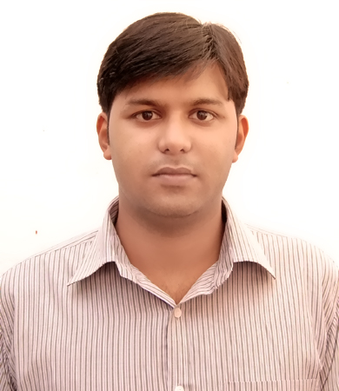

**PERSONAL OBJECTIVE:**

**To obtain a long term career with an organization that has a strong background that provides good opportunity for enhancement for professional and personal status.**

**CURRICULUM VITAE**

**Email ID/Skype ID:** [**shashikmishra89@gmail.com**](mailto:shashikmishra89@gmail.com)

**Mob: 7982557732/9555916267**

**SHASHI KUMAR MISHRA**

**SUMMARY OF QUALIFICATION**

* Strong verbal and personal communication skills.
* Decision making, critical thinking.
* Self-motivated, initiative, maintains a high level of energy.
* Accuracy and Attention to details.
* Tolerant and flexible, adjusts to different situations
* Organization and prioritization skills.
* Problem analysis, use of judgment and ability to solve problems efficiently.
* Hard working and flexible to work in shifts.

**Working Experince**

Working as “TEAM LEADER” in Mass Call Net India Pvt. Ltd. from 21st Sep, 2013 to till date. (Nextra ISP Process)

*Present Address*

*B 43,1st floor, Raju Park,*

*Khanpur, New Delhi-110062*

*Passport Data:*

*Passport no. M2576122*

*Date of issue 21-10-2014*

*Date of expiry 20-10-2024*

*Place of issue Delhi*

*Permanent Address*

*HNo. 84/A, Gopalpur Tola Katingpara, Village-Gopalpur Part, PS-Ghatsila, DIST- East Singhbhum, Ghatsila-832303*

*Technical Skills*

*Knowledge of MS-Office*

*Proficient in Web application and their functioning (internet and Search engines)*

*Address*

*C 126 A, Raju Park,*

*Khanpur, New Delhi-110062*

*Passport Data:*

*Passport no. M2576122*

*Date of issue 21-10-2014*

*Date of expiry 20-10-2024*

*Place of issue Delhi*

*Technical Skills*

*Knowledge of MS-Office*

*Proficient in Web application and their functioning (internet and Search engines)*

*Present Address*

*B 43,1st floor, Raju Park,*

*Khanpur, New Delhi-110062*

*Passport Data:*

*Passport no. M2576122*

*Date of issue 21-10-2014*

*Date of expiry 20-10-2024*

*Place of issue Delhi*

*Permanent Address*

*HNo. 84/A, Gopalpur Tola Katingpara, Village-Gopalpur Part, PS-Ghatsila, DIST- East Singhbhum, Ghatsila-832303*

*Technical Skills*

*Knowledge of MS-Office*

*Proficient in Web application and their functioning (internet and Search engines)*

*Address*

*C 126 A, Raju Park,*

*Khanpur, New Delhi-110062*

*Passport Data:*

*Passport no. M2576122*

*Date of issue 21-10-2014*

*Date of expiry 20-10-2024*

*Place of issue Delhi*

*Other Certifications*

*NEBOSH (HSW)*

*Certified*

*Safety, First-Aid & Disaster Management From Indian Red Cross Society, Jamshedpur*

*Diploma in Industrial Safety Management From Indian Institute of management & Technology ,Chennai*

*Technical Skills*

*Knowledge of MS-Office*

*Proficient in Web application and their functioning (internet and Search engines)*

***Responsibilities***

* Work with management to supervise our staffs and daily customer service operations.
* Create reports to update the company on the team's progress, deviation and plans using MS-Excel.
* Monitor team members' participation to ensure the training they providing is being put into use, and also to see if any additional training is needed
* Develop a strategy the team will use to reach its goal.
* Contribute to a positive and fun work environment.

***Achievements***

* Increment in salary within 5 months on basis of performance.
* Promoted as Team leader within 6 months in Mass Call net India Pvt. Ltd.

**EDUCATIONAL QUALIFICATIONS**

* BBA FROM PERIYAR UNIVERSITY(2012)
* I.SC FROM JHARKHAND ACADEMIC COUNCIL (2007)
* 10TH FROM JHARKHAND ACADEMIC COUNCIL (2005)

**PERSONAL DETAILS**

FATHER’S NAME: Late. G. S. Mishra

DATE OF BIRTH: 14-02-1989

RELIGION: Hindu

SEX: Male

MARITAL STATUS: Married

LANGUAGE KNOWN: English & Hindi

**HOBBIES & INTERESTS**ang out with friends and family, watching TV (Movies), playing cricket on weekly basis, chats with friends and family on social networking sites, listening music.

**DECLARATION**

I do hereby declare that all the statements as mentioned above are true and correct to the best of my knowledge and belief. I bear the responsibility for the correctness of the above mentioned particulars.

Date:

Place:

**SHASHI KUMAR MISHRA**