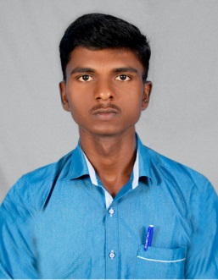**RESUME**

**M.LAKSHMANAN**

**E-mail:lakshmanandme98@gmail.com**

**Contact No:9787952751**

**Career Objective:**

To develop our organization based on my ability and capacity and to work for the betterment of our company.

**Educational Qualification:**

|  |  |  |  |  |
| --- | --- | --- | --- | --- |
| **Qualification** | **Name of the institution** | **Board/University** | **Year of passing** | **percentage** |
| SSLC | Pope’s Memorial Higher Secondary School, Sawyerpuram. | TamilNadu State board | 2013 | 89% |
| Diploma Mechanical Engineering | IRT Polytechnic College Tirunelveli. | DOTE | 2016 | 78% |

**Computer Skills:**

* AutoCAD
* AutoCAD MEP Basics

**Area Of Interest:**

* Design and developing
* Automobile
* Production

**Implant Training :**

* Undergone TNSTC,Tirunelveli.

**Main Project**

* Gear Cutting Attachment in lathe.

**Extra Curricular Activities:**

* Fire and Safety Course

**Hobbies:**

* Reading Books
* Sports (Kabaddi)

**Personal details :**

Date of birth : 26/02/1998

Father's Name : Muthuraj.R

Nationality : Indian

Languages known : Tamil , English

Permanent Address : 39, Dharma Raja kovil Street,

Tirunelveli Town,

Tirunelveli - 627006

**Declaration**

I hereby that the above information’s are correct and true to be best of my knowledge and belief.

Place : Tirunelveli Yours Faithfully,

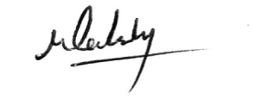

**(M.LAKSHMANAN)**