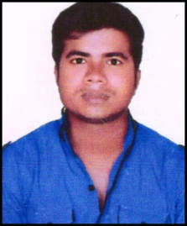 **CURRICULUM VITAE**

**SUDIST KUMAR**

VILL- MAJHAULIA MEHSI EAST CHAMPARAN BIHAR PIN 845426

**Mobile No.** +918791846471

**Email:-** sudist72@gmail.com

**CAREER OBJECTIVE:**

To be a part of an organization where I can utilize my skills and make a significant contribution to the success of the employer and at the same time ensure individual growth.

**QUALIFICATION:**

* **EDUCATIONAL QUALIFICATION**
* Passed 10th from BSEB Patna in 2011.
* Passed 12th from BSEB Patna in 2013.
* Pursuing B.Tech (ME) from AKTU, Lucknow.
* **Extra Knowledge:**
* Computer Basic.

**SUMMER TRAINING:**

* **45** days summer training in DLW, Varanasi (in 6th sem).
* **30** days summer training in HEC, Ranchi (in 4th sem).

**EXTRA CURICULAM:**

* Participated in Aero Modeling at college level.
* Participated in Seminar of Card India.
* Participated in Nuked Natick at college level.
* Participated in Cricket at College level.

**STRENGTHS:**

* Good Learner.
* Hardworking.

**HOBBIES:**

* Listening Music.
* Playing Cricket.

**PERSONAL DETAILS:**

Father’s Name : Mr. Hari Ram

Date of Birth : 14/10/1996

Gender : Male

Marital Status : Unmarried

Language Known : Hindi & English

**DECLEARATION:**

I hereby declare that the information furnished above is true and to best of my knowledge.

**Place:**

**Date: / / SUDIST KUMAR**