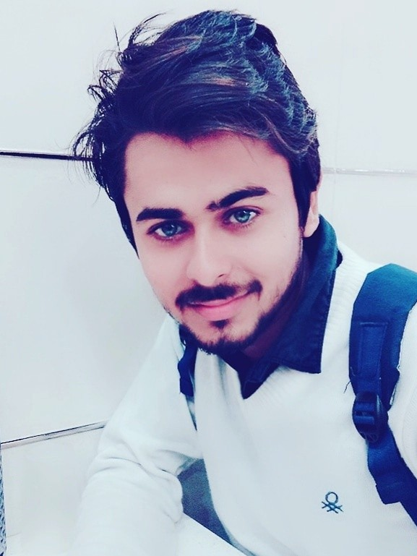**Saif Ali**

# Mobile:+91 99919 52626

**Email:**[alsaifali54@gmail.com](mailto:alsaifali54@gmail.com) **Address:**

*Delhi, India*

*Passport Number - T2984014*

**Objective:**

I seek a job as a Mechanical engineer in a construction company where I can use my ability. I wish to contribute towards organizational goals through my technical skills, hard work and creativity.

**Project Details**

**Project Title:**1. Industrial Training

**Description:**Summer vacation training (2018) from Goodyear pvt. Ltd. Faridabad which are worked on making moter vehicles tyres. I learned about many types of tyres in period of training.

**Duration:**45 Days **Role:**Member **Team Members:**6

**Project Title:**2. Cooling Pump

**Description:**The project cooling pump system is developed with the required good quality products.

**Duration:**3 Months **Role:**Team Member **Team Members:**5

**Education**

|  |  |  |  |
| --- | --- | --- | --- |
| **Institution** | **Major** | **Year of Passing** | **Percentage/CGPA** |
| Jeevan Jyoti Sr. Sec. School, Palwal ( India ) | 10th | 2015 | 80 |
| Government Polytechnic, Nilokheri ( India ) | Diploma in Mechanical Engineering | 2018 | 62 |
| Haryana Open School, India | 12th, Science ( Non - Medical  ) | 2018 | 60 |

**Field of Interest**

Leading of any group and Management

**Skills**

Communication skills Ability to learn

Time management Attention to details

**Strengths**

Hard working and result oriented Leadership

Quick learner

**Hobbies**

Learning in Mechanical ﬁeld

**Personal Details**

**Father's Name :** Mr. Jakir Hussain

**Date of Birth :**11-12-1999 **Gender :** Male

**Marital Status :** Single

**Nationality :** Indian

**Languages Known :** English, Urdu, Hindi

**Declaration**

# I hear by declare all the information provided on my resume is accurate or true.

**Place :** Delhi

**Date :** 03-02-2019

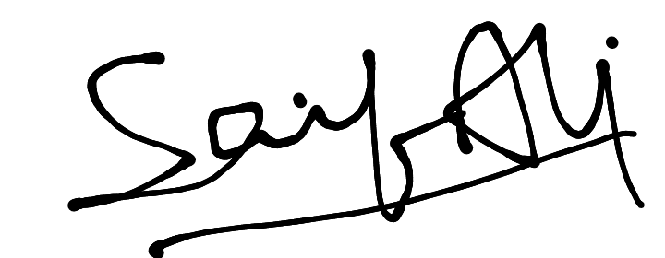

(SAIF ALI)