**RESUME** 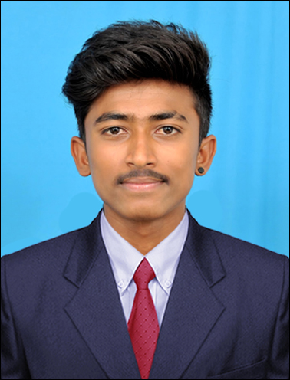

**V.RAJKUMAR**

Al Muteena Deira, Dubai –UAE

Mob: 0569212851

E-Mail: vraj19982@gmail.com

|  |
| --- |
| Education Qualification |

|  |  |  |  |  |
| --- | --- | --- | --- | --- |
| **Course** | **Institution** | **Board** | **Year of Passing** | **Marks (%)** |
| **Diploma in Mechanical Engineering** | **Vignesh polytechnic college Tiruvannamalai** | **Dote** | **2016** | **75%** |
| **10th std** | **Ramu Reddiyar Higher Sec School (Karungalikuppam)** | **State Board** | **2013** | **70%** |

|  |
| --- |
| Experience |

* Worked as Material Quality Checking in **Fourisiya Private Limited – Tamilnadu, India.**
* Duration – From March 2017 to February 2018.

|  |
| --- |
| Technical Skills |

* Material Quality Checking
* Rapping, Shipping.

|  |
| --- |
| AREA OF INTERST |

* Maintenance
* Quality
* **Production**

|  |
| --- |
| COMPUTER KNOWLEDGE |

* MS Office

|  |
| --- |
| MY HOBBIES: |

* Listening music
* Volley ball Playing

|  |
| --- |
| PROJECT DETAILS: |

**Project Title:** Design and Fabrication Accident Aviding Punching Machine

**Duration** : March 2016 to May 2016

|  |
| --- |
| PERSONAL PROFILE: |

Father‘s Name : R.VENKATESAN

Date of Birth : 27.07.1998

Gender : Male

Marital Status : Single

Nationality : Indian

Passport No & Validity : R0865094 & 19/06/2027

Visa Type : Tourist –Single Long

Visa Period : 23/03/2018 to 22/06/2018

Religion : Hindu

Languages known : Tamil and English

**DECLARATION:**

I do hereby declare that the particulars of information and facts stated herein above are true, correct and complete to the best of my knowledge and belief.

Date: YOURS FAITHFULLY,

Place: (V.RAJKUMAR)