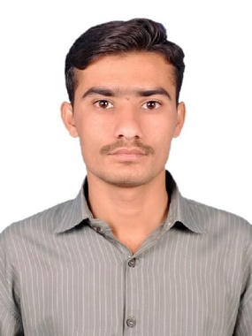 URRICULUM

ITAE

**GULFAM HUSSAIN**

**Mob: 056 9372014, 052 5400318**

**FATHER’S NAME : Haji RehmatHussain**

**Date of Birth : 25/12/1989**

**NATIONALITY : Pakistani**

**PASSPORT NO : RG6894072**

**Passport Expiry : 20/07/2020**

**E.MAIL :** [**Gulfam_hussain143@hotmail.com**](mailto:Gulfam_hussain143@hotmail.com)

**Visa Status : Visit Visa (Expiry Date: 03/02/2018)**

**WHATSAPP NO : +92-3453274585**

OBJECTIVE

To seek a challenging position in a progressive organization with an aim to contribute positively towards the objectives of the organization to the best of my capabilities, and to develop my professional skills. To become a productive participant of a professional team in a well-reputed organization that affords atmosphere of personal grooming and development, and to build there in a career leading to higher management position.

ACADEMIC QUALIFICATION

* **Matriculation From Lahore**
* **Intermediate From Karachi**
* **B.Com From Urdu University(Cont)**

**COMPUTER SKILLS:**

* **Ms. Office , XP Window , Internet .**

DIPLOMA



**HSE OFFICER** : 6 months Diploma in Safety Officer from **Pakistan Safety Institute**

* + - **OIL AND GAS SAFETY**
    - **CONSTRUCTION SAFETY**
    - **INTERNATIONAL GENERAL SAFETY**

CERTIFIED



**PROFESSIONAL CERTIFICATE PROGRAME**

* **OSHA Officer Certification**

**MODULE COURSE TITLE**

1. Introduction to occupational Safety and Health
2. Personal Protective Equipment
3. Confined Space
4. Scaffold Safety
5. Safety Supervision and Leadership Skills
6. Electrical Safety
7. Effective incident investigations



* Nebosh General Certificate 1&2 ( conti)
* Nebosh IGC 3 passed



* 3.2 Managing safely from (Safety First International)
* HABC Level 2 Fire & Safety From (UK Certificate)

DUTIES

Ensuring compliance with all current legislation, codes of practice and relevant standards.Investigate accidents and dangerous occurrences.

* Serving as the first responder to and investigator of safety incidents and mishaps
* Maintaining proper records.
* Ensuring that equipment is installed correctly and safely.
* Preparing reports by collecting, analyzing, and summarizing regulatory and compliance data and trends.
* Making regular site inspections.
* Producing concise reports for managers on Health and Safety matters.
* Advising Managers, colleagues of safe working practices.
* Conducting training courses.
* Carrying out safety inspections.
* Performing root cause analysis for incident/accident investigations.
* Producing risk assessments.
* Recording and investigating and accidents or incidents*.*

Keeping up to date with all new legistation and development in H&S and advising the business of any changes.

* Carrying out site safety inductions. Identifying staff training requirements.
* Maintaining an audit trail of all H&S documents. Assisting in the documentation of contractual agreements with third party organizations.
* Ensuring COSHH compliance is maintained.

WORKING EXPERIENCE

* **1 year worked in Javed engineering as aASST. SAFETY OFFICER.**
* **Present Job at PARAGON CONSTRUCTOR,s (PVT) as a SAFETY OFFICER.**

REFERENCE

Reference will be furnished.

**GULFAM HUSSAIN**