## Jauueoswe /\q pauueos

***RESUME­***

*(Mechnical)*

### *Permanent Address:­*

Vill:- Amahi Mishra Post :- Dubey ]igna Dist:- Gopal Ganj Pincode :- 841426

**Mo. No. +91 8808798638 E-mail ID:-** [**manishmishra497@gmail.com**](mailto:manishmishra497@gmail.com)

# Persona

**l.Deta**

#### Name

- **ils** :-



***MAN/SH KUMAR MISHRA***

Father's Name Date of birth Sex Nationality Religion Marital Status Hobbies

Language Known

Shri Ramakant Mishra

11/02/1996

Male Indian Hindu Unmarried Cricket

#### Hindi, English

**Educ.:at1on Qualification:-**



\

I

**Examination**

**Sr.**

**No.**

s.s.c.

01.

H.S. C.

02.

# Board/Univesity

!J.P. [Joan .I --

-- -- -

U.P. IJoard

I **Year of** j **Divis ii ­**

# Passing i

#### - ---- *r* ·--

##### 2010 ; 51 .9 9 }!1 :

- --- - - --- - - - --

Llll I (1(1.6%

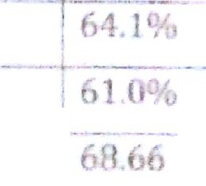03. I Diploma -1 J UPRTE LUCKNOW - - i 2(fr-J-

04. I Diploma -2 JurBTE LUCKNOW .. 201·l

I

_ 05 . I Diploma -3 UPB-T-ELUCKN0\\1- · - ;·T:tl lS

I - - -- - - - - - - ·-- - - - -- -- .. - - - · - ·- -- - --- --L--. --·-·

**Technical Qualification** :- **Diploma in Mccbnic::11** Enge. {P



► 6th Month of Experience in Quality Control.

Date: - nrs t•J ith fut1u

I Place: - ***1*** *I(U/\'lr*

*I*