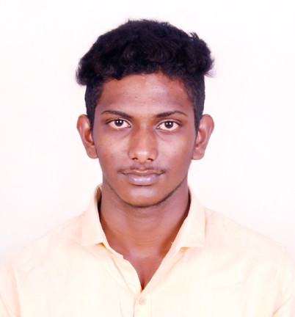**RESUME**

**KURALARASAN.M**

**2/163,WEST STREET,**

**SOUTH PATTAM,**

**VALANGAIMAN,**

**THIRUVARUR-612802**

**Contact no:+918940235795**

**Email:kuralarasanmrk522@gmail.com**

**Career Objective**

* Seeking a job position in a professional environment related to Mechanical Engineering. I have much interest to share my skills, knowledge and responsibility and will provide results that to glow along with the company.

**Profile**

* Young, Dyanamic, Hard Working, Smart Working & Result Oriented.
* If the Company has a shift I will handle the shift alonely.

**Skill Set**

**ppppp**

* Ability to work on transferable
* Ability to work in a team
* Ability to handle crisis

**Academic Record**

* SSLC from SIR MAHADEVA GURUJI,Valangaiman in year 2015 with 97.7%
* DME from Government Polytechnic College,Trichy-22 in year (2015-2017) with 70%

|  |
| --- |
| **Additional Course& Experiance** |

* AUTO CAD in Government Polytechnic College,Trichy-22
* 1 Year Experience at **ESSAR steel pvt.ltd,Hazira** in Mech Maintanance Engineer field

|  |
| --- |
| **Profile** |

**Name :** KURALARASAN.M

**Father’s Name :** MURUGAVEL.K

**Mother’s Name :** LAKSHMI.M

**Gender :** Male,

**Date of Birth**  **:** 26.07.1997

**Religion :** Hindu,

**Nationality :** Indian,

**Languages Known :** Tamil,Hindi&English.

References

|  |
| --- |
|  |

**FOR COLLEGE-**Mr.MURUGASEN,

HOD OF MECHANICAL DEPARTMENT,

GOVERNMENT POLYTECHNIC COLLEGE,

TRICHY-22

**FOR MECHANIC FIELD-**Mr.NARENDRA GUPTA,(9879106162)

HOD OF CRCA MECHANICAL MAINTANANCE,

ESSAR STEEL PVT.LTD,HAZIRA,SURAT

Declaration

I do hereby confirm that the information furnished above is true to the best of my knowledge and belief.

Place : Yours Sincerely

Date :