**CURRICULAM-VITAE**

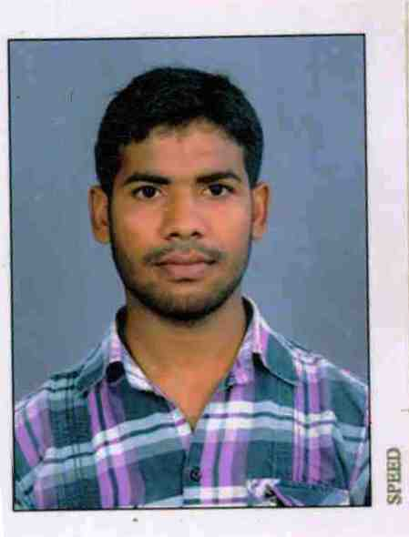

**VIPIN KUMAR**

**Address:-**

**A-579/4 New Ashok Nagar**

**New Delhi-110096**

Mb-: +919536093080, +919910095484

Email- [**vipin.kr.101@gmail.com**](mailto:vipin.kr.101@gmail.com)

CAREER OBJECTIVE

To have a growth oriented and challenging career, where I can contribute my knowledge and skills to the organizations and enhance my experience through continuous learning and team work.

PROFESSIONAL QUALIFICATION

B.Tech (**Mechanical Engineering**), from **Raja Balwant Singh Engineering Technical Campus**, Agra affiliated to **Uttar Pradesh Technical University**, Lucknow with year wise result as follows:

* B.Tech **4th** year with **82%** marks in 2015
* B.Tech **3rd** year with **68%** marks in 2014
* B.Tech **2nd** year with **63%** marks in 2013
* B.Tech **1st** year with **61%** marks in 2012

ACADEMIC QUALIFICATION

* **Intermediate** from **U.P. Board** with **65%** marks in 2008
* **High school** from **U.P. Board** with **62%** marks in 2006

INTERNSHIP

* Organization : TATA MOTORS PVT. LIMITED**, LUCKNOW**
* Description : Vendor Quality Assurance Department for Four Weeks.
* Training Period : Four Weeks.

PROJECT UNDERTAKEN

Analyses the hardness of material during turning process on CNC machine by using Taguchi’s method.

TECHNICAL SKILLS

* Application Software : Ms Office,
* Modeling Software : **AutoCAD**, **Pro-E (creo 3.0)**

CERTIFICATION

* Certificate in **AutoCAD**
* Certificate in **Creo 3.0 in (Part, Sheet metal, Assembly, FMS) certified by PTC**

ACHIEVEMENTS

* Campus selection in EPIC AUTOZONE PVT. LTD NAGAUR as TERITORY SALES MANAGER.
* Organizing the ABHYUDAY 2015 in college as the part of the organizing committee.

PERSONAL INFORMATION

Name : Vipin Kumar

Father’s Name : Mr. Satyadev Sharma

Date of Birth : 10/10/1992

Sex : Male

Marital Status : Unmarried

Language : English, Hindi

Nationality : Indian

Hobbies : Reading books& watching cricket, Web surfing for unique things

Permanent Address : Village-Takuawer, Po- Soron,

Dist-Kasganj (U.P) PIN-207403

DECLARATION

I hereby declare that the information furnished above is true to the best of my knowledge and belief.

**Date:**

**Place:** [VIPIN KUMAR]