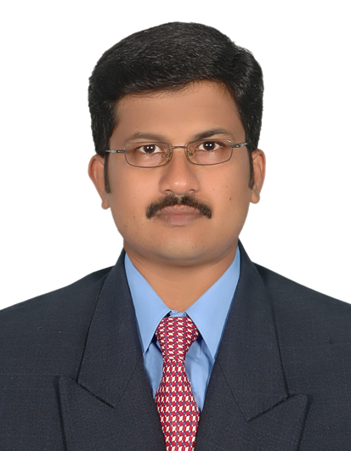

**ATHAVUL JAWAD S.M**

**Dubai, UAE**

**Mobile : +971 52 678 8286**

**Email: athavul@gmail.com**

|  |  |  |  |  |
| --- | --- | --- | --- | --- |
| **Objective** | | |  | |
|  | | A challenging position that will enable me to contribute to the organization goals availing an opportunity for growth and advancement. |  | |
| **Key Skills** | | |  | |
| * Trial Balance (Ledgers Balances). * Income statement, Balance Sheet, Cash Flow. * Keeping accounts of customers account (Debtors) * Keeping accounts of Suppliers Account (Creditors). * Preparing salary of all the Employees of the Company (Payroll) * Bank Reconciliation Statement (BRS-Banking). * Management information system (MIS). * Computers:-Ms Office (Ms Access, Excel, Word, PowerPoint) * Accounting package: Tally9   **Education** | | |  | |
|  | | **1995 1998** University of Madras, Chennai, Tamil Nadu.  Bachelor Of Commerce |  | |
|  | **1998 2000** University of Madras, Chennai, Tamil Nadu  Master of Business Administration (Finance) | |  | |
| **Employment** | | |  | |
|  | | **2014 - Present**  **Info-Drive Software LLC, Dubai.**  **Senior Accountant**   * Receive, register, verify and process all invoices and ensure transactions are correctly recorded. * Maintain and reconcile General Ledger accounts. * Monitor and review accounting and system related reports for financial accuracy and completeness. * On time Billing Invoices distribution & follow-ups for payments. Collection of payments / cheques from clients. * Process monthly payroll and maintain approved payroll records. * Banking transaction by manual and online (cheque deposits, cash receipt, payment transfer, cheque books etc.) * Review / Preparation of daily Journal Vouchers for all expenses with all supporting documents. * Checking / Reviewing of Journal Vouchers for correctness and proper approval. * Reviewing / Preparing Bank Reconciliation * To monitor/petty cash.. * Keeping up to date record of all accounting transaction * Establish, maintain, and coordinate the implementation of accounting and accounting control procedures. * Ensure accurate and appropriate recording and analysis of establishment expenses. * Keep updated the financial records. * Financial Reporting & audit preparation and coordinate the audit process.   **2010 - 2014**  **Openwave Computing (M) Sdn Bhd, Malaysia**  **Senior Accountant**   * Handle complete full set of Accounts. * Prepare weekly and monthly report for Accounts Receivable for Management. * Analyzes and reconciles General Ledger accounts with sub ledger. * Prepare set of account for Auditors. * Review and monitoring accounting entries and journal. * Maintaining capital asset records and determines proper depreciation rates. * Monitoring on account receivables aging and payables aging. * Handle Petty Cash. * Preparing payments to Suppliers / Creditors. * Handle Customer collection for Corporate, Distributors, Trading and Personal Effects. * Prepare Accounts Reports to Management – Profit and Loss, Trial Balance and Balance Sheet. * Prepare Bank Balance for daily. * Prepare Bank Reconciliation and prepare Summary to management. * Prepare salary to management staffs, executives and all other staffs. * Prepare income tax payments for PCB, EPF, and SOCSO for staffs. * Prepare service tax to custom. * Monitor staffs attendance and staffs leaves and update in record book. * Handle and purchase stationeries to company. * Handle staff welfare. * Handle office maintenance matter.   **2001 - 2010** .  **West Asia Maritime Ltd. Chennai.**  **Executive – Accounts**   * Creditor Management. * Scrutiny of Agency Disbursement & Master Disbursement Account. * Preparation of Invoices * Monitoring receivables and follow up. * Handling Forex transactions. * Preparation and presentation of MIS. * Preparation of Fund Flow. * Submission of monthly vessel accounts to owners and attending to any queries relating to accounts * Liaison with Bank, Income tax, Service tax and other statutory bodies. * Income tax & Service Tax – Filing Monthly / Annual returns, Issuance of Tax Deduction Certificates, follow up on refunds, Income tax Clearance Certificate, etc Liaison with Internal and Statutory Auditors * Finalisation of Accounts including preparation of Balance sheet.   **2000 – 2001**  **M/s. Shrieff & Co., Chartered Accountants, Chennai**  **As Audit Assistant**   * Balance Sheet Preparation for various clients * Visit for Internal Audit for various clients | |  |