***CURRICULUM – VITAE***

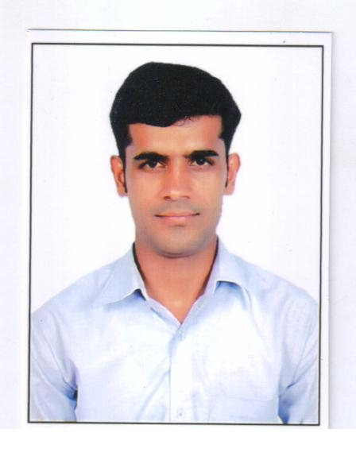

**SHOKEEN ALI**

**Address - Village+Post- Bachiti,**

**Distt-Saharanpur (U.P.),Pin Code-247551**

**Mob.No. - +919068562916, +917895787362.**

**Email Id** - [**shokeentyagi@gmail.com**](mailto:shokeentyagi@gmail.com)

**Passport No:- J2555558 Driving Licence**:- **MCWG, LMV Passport Type:- ECNR**

**Date of issue:- 19/07/2016**

**Validity:- 18/07/2036**

Skills:-

Communication **-** Deals with internal and external customers at all levels via telephone and email, to ensure successful communication via actively listening and probing questions.

Planning and organizing **-** Refined planning and organizational skills that balance work, team support and responsibilities in a timely and professional manner.

Systems knowledge **-** Experience in preparing and analyzing reporting data for management accurately and to .

**Educational Qualifications:**

|  |  |  |  |  |
| --- | --- | --- | --- | --- |
| **Degree** | **Board** | **Institution** | **Start** | **End** |
| BCA | HNB University | IMS College Roorkee . | 2007 | 2010 |
| XII | UP Board | Adarsh Inter College Telheri Buzurg, Saharanpur | 2006 | 2007 |
| XI | UP Board | Adarsh Inter College Telheri Buzurg, Saharanpur | 2004 | 2005 |

**Work Experience :-**

1. Worked as a **Computer Operator** in “**Data Matrix Solution Pvt. Ltd**. for a period from (02.05.2010 to 30.08.2012)
2. Worked as a **Data Entry Opeartor/Compoter Operator**  in **Samruddha Jeevan Multi State Multipurpose Co- Operative Society Ltd.**(From 26.Apr.2013 to 03.Feb. 2016)

**Gulf Experience:-**

* Worked as a **Data Entry Operator** in **Supermarket in Riyadh** for a period from (15.Sept.2016 to 20.May.2018)

**Job Description:-**

* Online software working.
* Daily update for excel sheet.
* Daily Recived items update for software and etc.

**Gulf EXPERCINCE:-** **20 Months**

**India EXPERCINCE**:- **5 Years and 2 Month.**

**TOTAL EXPERCINCE:- 6 Years and 10 Months.**

**Diploma Computer:-**

* One Year ***Basic Diploma of Computer***  from V.I.C Jhabrera, Roorkee.

**Computer Proficiency:**

• Computer Fundamental

• Ms Office

• Internet

• Networking

**Languages Known:-**

|  |  |  |  |
| --- | --- | --- | --- |
| **Languages** | **Read** | **Write** | **Speak** |
| English | Yes | Yes | Yes |
| Hindi | Yes | Yes | Yes |

**Personal Details:**

|  |  |
| --- | --- |
| **Father's Name** | Sh.Tayyab Ali |
| **Mother's Name** | Smt.Mahmuna |
| **DOB** | 20/07/1991 |
| **Sex** | Male |
| **Mother Tongue** | Hindi |
| **Hobbies** | Watching Movie and Cricket Playing |
| **Mobile** | +919068562916, +917895787362. |
| **Address** | Village+Post-Bachiti, Distt- Saharanpur UP 247551 |

**Declaration:**

• I hereby affirm that the details endowed are true to the best of my knowledge and belief.

Place ………………

Date ……………… **(SHOKEEN ALI)**