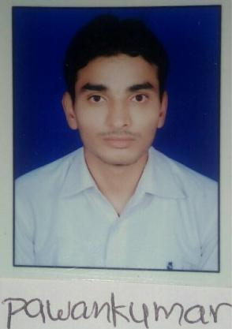Curriculum Vitae

Personal Information



**Name** Pawankumar Barnawal

**Date of Birth** 10/01/1994

**Place of Birth** kushinagar

**Marital Status** single

Contact Information



**Correspondence address** Bus-stand Pilkhuwa(245304), Hapur, U.P.

**Permanent address** Rampur bujurg, Post-Hata,Distt.-Kushinagar

**Mobile** 8756597001

**E-Mail** pawankumarbarnawal@gmail.com

**Social Media(LinkedIn)** https://www.linkedin.com/in/pawankumar-barnawal-361a8b129/

Education



|  |  |
| --- | --- |
| **2013-2017** | Graduate in mechanical engineering from Monad University Hapur, |
|  | Uttar-Pradesh with 64.5% marks. |
| **2012-2013** | Intermediate from U.P. Board with 62% marks. |
| **2008-2009** | High School from U.P. Board with 57.17% marks |

Languages



**Hindi** native

**English** communication level

Skills



**Computer**

Proficient in Auto-CADD, Solid-works, GD&T and basics of excel and in possession of a Bachelor's in Mechanical Engineering.

Summary: **I am graduate in Mechanical Engineering with a strong background knowledge in mechanical engineering, computer-aided design, solid-works and GD&T, I am hardworking, passionate about my working and confident that I can achieve any goal set before me. It is my objective to obtain a full-time position that will build my expertise to further advance my career with growth of the organisation.**



**Profession** mechanical engineer

Other



**Hobbies**

Reading & writing.

**Interested Area**

Working on New Task

Visiting New Place

Current affairs

News paper

**SALARY EXPECTATIONS:**

Market Rate.

**NOTICE PERIOD**

**DECLARATION :**

Immediately

I Hereby Declare That The Information Mentioned above is true and correct to the best of my knowledge.

**...**

...

**...**

PAWANKUMAR BARNAWAL