**CURRICULUM VITaE**

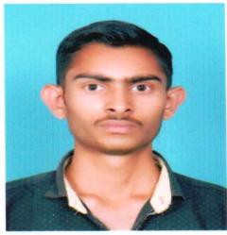

**RAVI KUMAR**

Address: V. P.O. Lamlehri, Tehsil & Distt. Una (HP) 174303 Contact No:- 8628904537

Email: [kmravi199806@gmail.com](mailto:kmravi199806@gmail.com)

**P. No: P5642827**

CARRIER OBJECTIVE:-To complete assigned task individually or in a team and co-operative with all member in the

organization facing challenges and resolving them.

# PERSONAL DETAILS-:

Father’s Name : Sh. Shamsher Singh

Date of Birth : 06/01/1998

Marital status : Single

Sex : Male

Religion : Hindu

Nationality : Indian

Passport No : P5642827

Passport Validity : 02/05/2017 to 01-05-2027

# EDUCATIONAL QUALIFICATION-:

* Matric from HP Board Dharamshala with 50% in 2014.

# TECHNICAL ABILTIES-:

* Excellent technical skills such as a civil helper, welding and furniture work.

# WORK EXPERIENCE:

* One year work experience as civil helper.

# SKILLS & ABILITIES:-

Self motivated, self disciplined, Good Communication-can read write speak English Hindi.

# HOBBIES AND INTERESTS:-

* Listening music.
* Playing Cricket & Driving.

DECLARATION:- I hereby declare that the above mentioned facts are True & best to my knowledge.

Date: Signature

Place: