# CURRICULUM VITAE

**Objective**

Being self motivated, I aspire to work in a demanding environment where I can apply my skills in developing innovative solutions, in a firm that value my ideas in a manner.

**Educational Qualification**

**Degree in Electronics And Communication (ECE)** (2012-2015) Maharaja Institute of Technology, Coimbatore.

**Diploma in Electronics And Communication(ECE)** (2008–2011) Government Polytechnic College, Nagercoil.

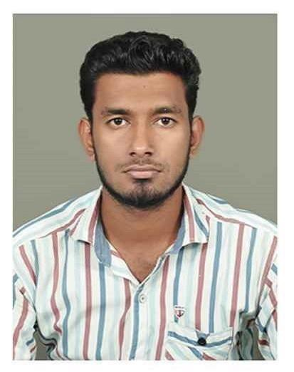

# JAIWIN

**PASSPORT NO : N0451489**

## Email ID : [jaiwinpm@gmail.com](mailto:jaiwinpm@gmail.com) Mobile : 9626838281

**Permanent Address**

* + 1. AIWIN,

s/o. P.Paul Xavier, 3/100, Church Street, Konamkadu & PO, Kanyakumari District, Pin:629-803,

|  |  |  |  |
| --- | --- | --- | --- |
| SL.NO | ORGANIZATION | FROM | TO |
| 1 | ZION DATA PRODUCTS | 11-05-2011 | 31-05-2012 |
| 2 | DIGILOG MICRO SOLUTIONS (P) LTD | 01-06-2015 | 31-12-2016 |

Tamil Nadu, India.

**SSLC** (2008)

VKP Hr.Sec.School, Colachel.

|  |  |  |  |
| --- | --- | --- | --- |
| Course | University | Year Of Passing | % Marks |
| Degree | Anna University | 2015 | 60% |
| Diploma | DOTE | 2011 | 75% |
| S.S.L.C. | State Board | 2008 | 92% |

**Experience**

**Technical Skills**

* + - * Basic in Computer Hardware
      * MS OFFICE

# Personal Details

Father Name : PAUL XAVIER Date of Birth : 12-10-1992

Sex : Male

Marital Status : Single

Nationality : Indian

Religion : Christian Languages Known : English, Tamil.

* **Platform –** Windows Server, Windows XP,

Windows Vista, Windows 7 & 8, Windows 10, Linux

**Project Work**

## DIPLOMA LEVEL

**Project Name :** MICROCONTROLLER BASED ELECTRONIC LOCK

## DEGREE LEVEL

**Project Name :** IMAGE QUALITY ASSESSMENT ON FAKE

BIOMETRIC DETECTION



**Areas of Interest**

* + Electronics
  + Software

**My Strengths**

* Sincerity and Adaptability.
* Perform well under pressure.
* Good Team Worker

**Extra-Curricular Activities**

* Attended Workshop (Android Controlled Robotics) in SRM University, Chennai.
* Participated in District Level 10 Days National Service Scheme.

**DECLARATION**

I hereby declare that the information furnished above is true to the best of my knowledge.

**Place: KONAMKADU**

## Date: 13/02/2017 P.M.JAIWIN