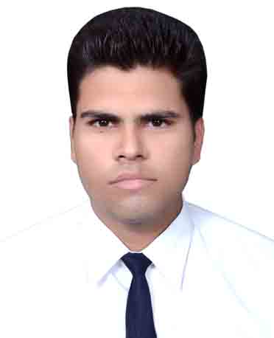

|  |
| --- |
| **Career Objective** |

|  |
| --- |
| Seeking a career that is challenging and interesting and lets me work on the leading areas of technology, a job that gives me opportunities to learn, innovate and enhance my skills and strengths in conjunction with company goals and objectives. |

|  |  |  |  |  |  |
| --- | --- | --- | --- | --- | --- |
| **Professional Qualification** | | | | |  |
| **Degree** | **Board / University** | **College / Institute** | **Branch** | **Yr. of Passing** | **% of Marks**  **(overall)** |
| B.Tech | Teerthanker Mahaveer University | College of Engineering | Civil Engineering | 2014 | 66.52 % |

|  |  |  |  |
| --- | --- | --- | --- |
| **Educational Qualification** | | | |
| **Degree** | **Board / University** | **College / School** | **% of Marks** |
| **12th** | UP Board | 1. W. Faiz-e-aam Inter college, Amroha | 64.40% |
| **10th** | UP Board | Kundan Model Inter college, Amroha | 59.66% |

|  |  |  |  |  |
| --- | --- | --- | --- | --- |
| **Summer Internship** | | | | |
| **Company Name** | **Duration** | **Topic** | **Learning** | **Place** |
| Central Public Work Department  (CPWD) | One Month | Structural Design And Detailing of RCC Structures | Designing on STAAD Pro v8i | Nirman Bhavan, New Delhi |
| Arvind Techno Engineers Pvt. Ltd | Four Weeks | Construction of Railway Bridge on Rup Narayan River | Pile Foundation, Segment , Mould | Kolaghat, Kolkata |

|  |  |  |  |  |
| --- | --- | --- | --- | --- |
| **Experience** | | | | |
| **Company Name** | **Duration** | **Work** | **Designation** | **Place** |
| Krishna Contractors Co. | 11 months (still working) | Residential Project,  S.T.P | Site/Billing Engineer | Garhmukteshwar |
| Chaudhary Construction Company Pvt. Ltd. | 10 months | Building Construction | Civil/Billing Engineer | Various sites in Delhi |
| **key Responsibilities-**   1. Making Bills (Shuttering, Concrete, Reinforcement), BOQ, BBS, MB, Work Charts and Reports. 2. Checking shuttering and quality. 3. Checking reinforcement and Casting. 4. Checking level and Quality of sewer line/Manholes. 5. Deal with clients in Inspections and Meetings. 6. Monitoring work progress and daily update to the superior through written & tele conferencing. 7. To ensure that the Civil Work/Sewer Line Installation/Mould is going on according to the Approved Drawings. 8. Identify options and recommend solutions to resolve technical issues. 9. Attending project site selection studies. 10. Mentoring and supervising junior staff. 11. Compiling, checking and approving reports. 12. Ensuring that all assigned work is completed on time and within agreed budgets. 13. Working closely with all levels of management, engineers and field operations staff. 14. Providing support in the preparation of technical reports, cost estimates and contract documentation. 15. Participating in technical site surveys. 16. Dealing with complaints from local people experiencing disruption due to building works. | | | | |

|  |
| --- |
| **Extra Co – Curricular Activities** |

|  |  |
| --- | --- |
|  | Organizing many intra college cultural/sport events. |
|  | Social work. |
|  | Anchalik Bal Vigyani, National Children’s Science Congress, U.P, 2005. |
|  | Zila Bal Vigyani, National Children’s Science Congress, U.P, 2005. |

|  |
| --- |
| **Computer Skills** |

|  |  |
| --- | --- |
|  | Certified in AutoCAD by CADD Centre Training Services, Moradabad, India. |
|  | Basic knowledge of STAAD PRO v8i. |
|  | Well versed with MS – Office and Internet Application. |

|  |
| --- |
| **Personal Details** |

|  |  |  |
| --- | --- | --- |
| Date of Birth | : | 3 August 1991 |
| Father’s Name | : | Shahab Ahmed Rizvi |
| Marital Status | : | Single |
| Language Known | : | English, Hindi. |
| Hobbies | : | Watching Movies, Arts and Crafts, Writing. |
| Strength | : | I am able to work even under pressure & Accept Challenges. |
| Permanent Address | : | Rizvi House, Mohalla Peerzada, Amroha, U.P - 244221 (INDIA). |

|  |  |  |
| --- | --- | --- |
| Place: Garhmukteshwar | Date: | SAYED HAMZA RIZVI |