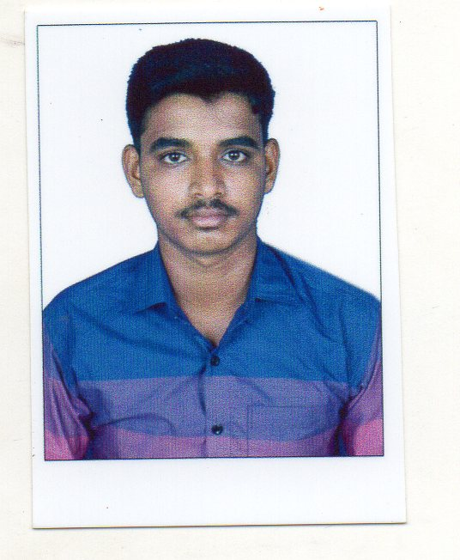 **RESUME**

**objective**

To get a growth oriented position in a reputed organization where my skillcan be utilized for improvement and success of the organization.

**EDUCATION**

**10th — STATE BOARD**

Institution: ST.LITTLE FLOWER MATRIC HIGHER SEC SCHOOL TRICHY

Year of passing: 2013

Percentage: 74.56%

**Skill SET**

**Technical**:

WIRING h. handling the raping machine

ELECTRICAL MAINTENANCE A AIR-CONDITIONER SERVICES

**Non-Technical :**

§ Honest and hardworking

§ Willingness to learn

§ Good team player

§ Good communication skills, optimistic and positive attitude **CERTIFICATIONS:**

SSLC CERTIFICATE **Personal Details**

NAME : N.MOHAMED RAFIK D.O.B : 19-12-1997 FATHER' NAME. :A.NAGOOR MEERAN Mothers name : N.HIRUN NISA BEGAM

/ Civil Status :Male/ Single Nationality : Indian. Passport no. : M6519931. Visa status. :current Jebel Ali free zone visa. EXPERIENCE: one year general helper in Alinox steel alloys fze 2017to2018

contact no : +971524050561

**DECLARATION**:

I hereby declare that all the information mentioned above is true to my knowledge and I bear the responsibility for the above mentioned particulars.

DATE: YOURFAITHFULLY**,** **PLACE**: TRICHY **N.MOHAMED RAFIK**