**RESUME**

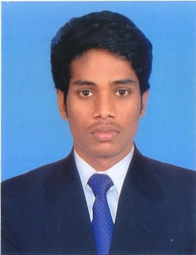

**Mr.A.RAMESH**

s/o. V. Ananda Raju, No: 151, big street, Koramangalam, Tiruttani (tk), Tiruvallur (dt) Tamilnadu, India-631205.

**E-mail**-Rameshanand.vram@gmail.com

**Skype** - Ramesh42836

**Contact no**-+919626181685



PROFESSIONAL OBJECTIVE**:**

To seek a challenge career and add value to the company by using my functional and experience and interpersonal skills.

**WORK EXPERIENCE:**

**COMPANY:** R.B.C Engineering

**POSITION :** Machine operator, Quality checking and maintenance

**PERIOD :** May 2015 to Present

**JOB RESPONSIBILITIES**:

* Maintains safe operation by adhering to safety procedures and regulations. Create and maintain activity logs.
* Documents actions by completing production and quality logs.
* Complete all reports and other paperwork associated with machining projects In process.
* Working with other professionals, within and outside the Engineering sector.
* Maintains system and product database by writing computer programs and entering data.
* The ability to work under pressure.
* Ensure that regular and preventative maintenance procedures are carried out.
* Accomplishes organization goals by accepting ownership for accomplishing New and Different requests; exploring opportunities to add value to job accomplishments.

**EDUCATIONAL QUALIFICATION**

S.S.L.C**:**

Govt. Hr. Secondary School

Passed Out Year Of 2007 to 2009.

Hr.Sc School:

Govt. Hr. Secondary School

Passed Out Year Of 2009 to 2011

**DIPLOMA IN MECHANICAL ENGINEERING**

**INSTITUTE**:

Vethathiri Maharishi institute of technology

Passed out Year Of 2012 to 2015. [78%]

KNOWLEDGE, SKILLS AND ABILITIES:

**COMPUTER SKILLS:**

* CAD [2D, 3D], MS OFFICE,

**PROJECT DONE BY**:

* PICK AND PLACE ROBOT

PERSONAL DETAILS:

|  |  |
| --- | --- |
| Date of birth | : 16th may 1994 |
| Nationality | : Indian |
| Marital status | : Single |
| Passport no. | : N3985188 |
| Passport validity | : 27-10-2025 |
| Languages known | : English, Tamil, Telugu, Kannada  . |

DECLARATION:

I hereby declared that the information mentioned above is true and constant to the best of my knowledge.

PLACE: CHENNAI A.RAMESH