**Curriculum Vitae**

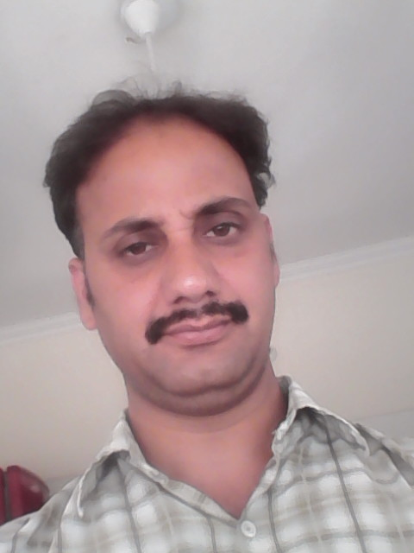

**Santosh Kumar Bhatt**

Major.S.B Dutt,Guru Dwara colony

Clement Town

Dehradun(U.K)

Ph.No.9410576161

EMAIL ID: Beliwal.santosh3@gmail.com

**PERSONAL INFORMATION:**

* **Date of birth 15/04/1977**
* **Father, name Late Purshottam Bhatt**
* **Gender Male**
* **Marital status Married**
* **Languages known Hindi,English**
* **Nationality Indian**

**ACDEMIC BACKGROUND:**

* **B.A from H.N.B Garhwal University. 1999**
* **Intermediate from UP Board. 1996**
* **High School. from UP Board. 1994**

**PROFESSIONAL BACKGROUND:**

* **M.Sc in (I.T) from Uttaranchal Open University(2014)**
* **PGDCA from Hiltron(2010)**
* **B.Lib.sc from IGNOU(2011)**
* **M.Lib.sc from Algappa University (2014)**

**PROFESSIONAL EXPERINCE:**

* **Two Year Experience of Librarian in Public Library in “Devprayag” (Garhwal,Uttrakhand)**
* **Ten Year Experience of “Assistant Librarian” in “Graphic Era Deemed University” (Dehradun, Uttrakhand)**

**LIBRARY SKILL :**

* **Help patrons in finding the necessary reference materials**
* **To renew or order new subscription to Journals, Magazines, Newspaper.**
* **Prepared necessary reports and records as required**
* **Process new materials including books, Journal, Magazines etc.**
* **Located and checked out resource materials (books and tech equipment) to faculty, staff, and students.**
* **News paper clipping etc.**
* **Operated the circulation desk.**
* **Performed circulation desk procedures and shelved library materials.**
* **Cataloguing and classification.**

**KEY SKILL:**

* **Good interpersonal skill**
* **Proficient in English, Hindi.**
* **My convincing power.**
* **Efficiency in computer course.**
* **Hard Working and sincere.**
* **Quick Learning ability.**

**HOBBIES:**

* **Listening to music**
* **Reading books**
* **Traveling**
* **Yoga**

**LANGUAGE SKILL :**

* **Hindi**
* **English**

**COMPUTER SKILL:**

* **General basis of computer Hardware and software.**
* **Good in Using MS Office.**

**I declare that all the information provided by me in this application is correct to the best of my knowledge and belief.**

**DATE: 1August-2017**

**PLACE: Dehradun SANTOSH KUMAR BHATT**

**Apply post for -Store keeper**