**VIJAYARAJA A** 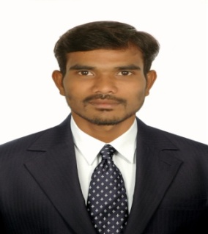

25/15, K R Ramasamy Nagar, Velachery Main Road

Opposite Police QTS, Velachery, Chennai – 600 042

Email: vijayaraja.6253@gmail.com

Phone No : +919566856253

Professional Summary

Experienced and skilled Shipping Specialist utilizes good knowledge of shipping and receiving in manufacturing environments. Has strong communication skills and is able to work as an integral team member.

Core Qualification

* 6 years experience in e-publishing field
* Export & Import Clearance
* Filing Checklist Export & Import (ONS Software)
* Documendation Work
* Excellent oral communication skills
* Proficient with computer and Microsoft Outlook, Excel and Word
* Strong understanding of shipping and receiving processes
* Good experience working in CHA
* Good ability to work as a valued team member

Internship

1. **Ragavandhra Shipping Services, Andhra, Visakhapatnam.** 21-Sep-17 to 18- Nov-17

Experience

**1. Spi Global Pvt Ltd (Laserwords) Chennai.** March -2013 to July -2017

**2**. **Scientific Publishing Services Pvt Ltd, Chennai.**  July-2011 to Feb -2013.

Education Qualification

|  |  |  |  |
| --- | --- | --- | --- |
| **Qualification** | **Name of the Institution** | **University / Board** | **Year of Passing** |
| Professional Diploma (Logistics & Shipping) | Indian Institute of Logistics, Chennai |  | 2017 |
| D.M.E (Mechanical) | Arulmigu Kallalagar Polytechnic College, Melur | Anna University | 2010 |
| H.Sc | Gov. Hr.Sec.School | State Board | 2007 |
| S.S.L.C | Gov. Hr.Sec.School | State Board | 2005 |

Technical Skills

Operating System **:** Windows (XP, 2007, 2008)

Office-Tools : MS-Office (Word, Excel, PowerPoint)

Other : Adobe Professional (Acrobat, Photoshop), Typewriting, FTP

Personal Detail

**Name** : Vijayaraja A

**Father’s Name** : Alagar K

**Date of Birth** : 24 May 1990

**Sex** : Male

**Nationality** : Indian

**Languages Known** : English, Tamil.

**Permanent Address** : 665/4-80, Patcheri, Gandhi Nagar, Kalloorani (post),

Sivagangai (Tk), Sivagangai (Dist),

Pin code – 630 561.

Place : Chennai

Date : Your's faithfully

(VIJAYARAJA.A)